JOURNAL on INTELLIGENT ROBOTICS systems
Manuscript Submitted — 2025 | Original Research Article
Online Adaptive Lyapunov-Stable Drone Control with CBF Obstacle Avoidance, Neural Sensor Fusion, and Real-Time Path Replanning
RITHWIK SATYA SAI GANESH DUDALA
Registration No: CH.SC.U4AIE24089
CH.SC.U4AIE24089@students.amrita.edu
Department of Computer Science and Engineering, Amrita School of Computing, Amrita Vishwa Vidyapeetham,
Chennai, India T. Vijay Rama Reddy
Registration No: CH.EN.U4RAI24038
Ch.en.u4rai24038@ch.students.amrita.edu
Department of Mechanical Engineering, Division of Robotics and Artificial Intelligence
Amrita Vishwa Vidyapeetham, India
Abstract
The article gives a thorough discussion of architecture of a simulated autonomous drone control system, in which six interdependent subsystems are assembled to create one flight controller that is safety-certified. The framework addresses the fundamental issue of deploying smart aerial vehicles within the unstructured and barrier-infested three dimensional space in which real time stability is needed, collision avoidance and state estimation must be run in parallel and harsh computational constraints exist.
This system is programmed into six working aspects. Phase 1 The dynamics of a rigid-body quadrotor is defined by a quaternion-based attitude representation devoid of the gimbal lock and providing orientation tracking with a globally nonsingular orienting frame. Phase 2 entails the introduction of adaptive Lyapunov controller online, which the Multilayer Perceptron (MLP) builds on a nominal geometric controller on which the learning rate is adjusted to the sign and magnitude of the Lyapunov derivative dV/dt. To enforce hard collision-avoidance blocking, Phase 3 applies Control Barrier Functions (CBFs), based on which the joint CBF-CLF minimisation programme weighting between tracking objectives and safety ones is formulated. Phase 4 executes web-based parameter conformation that ensures convergent limits and learns aerodynamics disruption and Mass alteration and quantifies the adaptive latency. Phase 5 introduces a sensor fusion observer that utilizes neural-networks to design sensor fusion to fuse the IMU and GPS measurements which are noisy and assuming sensor fusion would provide trustworthy outputs of the state in the situation of real sensor noise. Phase 6 implements three-dimensional real-time path replanner by probabilistic RRT+ algorithm that reinvokes itself when obstacles are detected in the resumption of the replanning events where Lyapunov continuity is realized.
The framework has an average Lyapunov energy reduction of 99.3 percent and a mean EBF safety margin of more than zero on six phases of benchmark suite, a neural observer position error of less than 0.12 m with sensor noise of 5 percent and RRT+ replanning has been done in less than 45 ms. The entirely implemented system is discoverable in Python using NumPy and Matplotlib even in the absence of any deep-learning or optimisation libraries, creating all the algorithmic execution actions auditable and observable inside embedded flight controllers.
Keywords: drone control, Lyapunov Stability, Control Barrier functions, Neural Sensor fusion, RRTyear path planning, Quaternion Dynamics, Adaptive SGD, Online learning, CBF quadric program Obstacle avoidance, Aerial robotics.
Introduction
The external control of autonomous unmanned aerial vehicles (UAVs) is challenged with an inherently more complicated problem than control over surface-bound mobile robots. The drone does have six degrees of freedom, has inherently unstable underactuated dynamics, with attitude and position coupled with nonlinear thrust equations. Onboard IMU sensor noise is directly propagated into state estimates, the aerodynamic drag is sensitive to the velocity in a way that two-pole controllers can no longer control, and the three dimensional structure of the operating space produces obstacle formations, which cannot be solved by two-dimensional path planners. The aerial systems also have safety requirements that are more category-theoretic: any single violation of a constraint, such as a missed obstacle, uncontrolled perturbation of attitude, sensor fusion failure, etc. may lead to unrecoverable crash.
Classical schemes of UAV control are based on cascaded PID schemes, and no attitude-position combinations are considered. Although tractable, well-understood, and operationally stable, PID controllers have no formal stability guarantees when using large disturbances, cannot think explicitly about the proximity of obstacles, and gracefully degrade only in a limited operating space. Efforts to operate across unstructured scenes within unstructured environments are restricted by Model Predictive Control [3], which again limits itself to a hillar foreground that funds accurate dynamic modelling, and prediction environment that is convex or near-convex. SO(3) geometric controllers[4] are non-natively native to obstacle avoidance or model uncertainty, and offer global exponential stability to the attitude tracking problem.
It has been shown in the literature of the neural Lyapunov control [1][6][7][8][9], that a neural network can co-learn a controller and a Lyapunov certificate it has, which provide formal stability with no analytic function of the Lyapunov and no requirement that its Lyapunov affect any specific form of stability. Nevertheless, most of these methods need offline pre-training, involves solver-dependent verification (MILP, SMT, branch-and-bound), and most methods have been tested successfully only on planar mobile robots or low-dimensional toy systems. To apply these concepts to a six-degree-of-freedom drone that can work in three dimensions, realistic parameter sensor noise, real-time parameter adaption and replanning of obstacles make it necessitate a richer architectural exposition.
Control Barrier Functions (CBFs) [20] offer an additional safety measure. CBFs unlike Lyapunov functions which assure a system state convergence to a goal assure the system state at all future times lies in a defined safe set. The CBF-CLF Quadratic Program (QP) frame [20] combines the two objectives and at each timestep chooses a control input which satisfies a Lyapunov decrease and CBF forward invariance simultaneously. This framework has been used in ground vehicle case [20] and manipulation case [21] but with low application in aerial vehicles with full quaternion attitude control and online neural augmentation.
In order to fill in these gaps, the paper provides a six-phase integrated architecture of drone control, which is (1) formally Lyapunov stable with an online adaptive neural controller; (2) hard-safety admitted with CBF constraints; (3) faithful to sensor noise with neural fusion; (4) adaptive to aerodynamic parameter change; and (5) capable of real-time three dimensional path re-planning. Contribution is not any one of the six parts in particular but rather the harmonious combination of all six parts into a single solver-free framework-free system that has been tested by the most extensive simulation possible.
This paper is organized in the following way. Section 2 is the review of the related literature. Section 3 represents the formulation of the mathematical problem, including complete quadrotor dynamics. Section 4 explains the architecture of the system. In section 5-10, all six phases are detailed. Ablation and comparative analyses are represented in section 11. The limitations are covered in section 12. Section 13 concludes.

Literature Review
2.1 Classical Lyapunov Stability in Robotic Control
The idea of classical Lyapunov Stability in robotic control is presented in
Most rigorous stability studies in robotic systems are based on the direct method developed by Lyapunov [12]. In a closed-loop system with a differential-equations model and an asymptotic stability candidate in the form of a Lyapunov function V(x) is a positive-definite Lyapunov function with the property that V(x)/ dt on system trajectories is negative. In tracking the control, V is often written as proportional to a tracking error vector e = q - q des and the running of a control law is to make dV/dt negative. This framework is used in classical computed-torque, adaptive and sliding-mode manipulator controllers [11][13] all of which operate based on this framework. The most crucial constraint of deployment lies in the fact that one needs to build a conducive V in an analytic fashion, which becomes unintenable when the dynamics of the system are nonlinear in high dimensions as well as when learned components are involved.
In this section, we discuss the geometric control of SO(3) of the quadrotors.
Noticing that when a quadrotor is run on a Lie group, namely the SO(3), the geometric tracking controller in the Lie group is derived to achieve local coordinate singularities-free exponential stability of attitude tracking [4]. The controller is based on Riemannian metric on SO(3) to come up with an intrinsic error and thus is easy to make compatible with quaternion representations. This paper has set the gold plateau of quadrotor attitude regulation and inspired the adoption of quaternion usage in Phase 1 of the current architecture to circumvent the gimbal lock situation of the Euler-angle representations.
2.3 Neural Neural Lyapunov Functions and Neural Controllers.
Lyapunov Neural Network proposed by Richards, Berkenkamp and Krause [1] trains both a neural controller and a neural Lyapunov certificate with Lagrange multipliers to penalise breaches of the descent condition. Dai et al. [6] generalized this to collectively stable neural control together with global stability proofs through MILP. To lower the cost of certification, Yang et al. [8] substituted MILP with branch-and-bound accelerated with the use of GPUs. Lu et al. [9] implemented (Lyapunov) structural inductive biases as structural injections into the network. Agand et al. [14] observed online adaptive stability learning through RNN-based identification. The current text generalizes such concepts to three dimensional drone dynamics with CBF integration, sensor fusion, and replanning none of which has been concurrently studied in the neural Lyapunov literature.
2.4 Control Barrier Functions
The Control Barrier Functions developed by Ames et al. [20] are the Lyapunov-analogous safety tool: a control-barrier tool, h(x), is a valid CBF when there is a control input-described by the admissible set, and an alpha such that the CBF, dh/dt + alpha(h) >= 0, is satisfied. The CBF-CLF QP also integrates the aspects of safety and convergence into a small quadratic problem that is solved at every step. It has widely been applied to bipedal walking and ground vehicle collision avoidance
contributed applications [20]. The current paper deploys CBF-CLF QP in a 6DOF drone model that uses quaternion attitude, but considers the obstacle fields as designed in 3D position space as a sphere constraint.
2.5 UAV Sensor fusion and military estimation.
UAV state estimation has been an Extended Kalman Filters (EKF) problem since the initial efforts by Mahony et al. [22]. Recently, observer designs based on neural networks have demonstrated better performance in the case of non-Gaussian noise and model mismatch [23]. The conditioned MLP observer presented at the moment does not have to train a linearisation of the model needed to estimate the measurement linearisation at every step as the EKF does, but rather fuses measurements of IMU acceleration and GPS position values to achieve results in movement prediction and control without actually having to linearise the measurement model.
2.6 Sampling-Based path planning in three dimensions.
The Rapidly-exploring Random Tree (RRT) [18] and its more optimal counterpart RRT [24] are both endsowing planning solutions that are probabilistically complete and asymptotically optimal for tractable configuration spaces that are high-dimensional. The UAVs have deployed real-time replanning extensions including RRT-Connect and Dynamic RRT [25]. The current paper instantiates RRT in three-dimensional position space of the drone with the inflation of obstacle radii to guarantee the safety margin, and replanning events and Lyapunov continuity to be implemented to guarantee that stability is preserved between the trajectory transitions.

3 Formulation of the Problems in Mathematics.
In this paper, we examine the dynamics of a quadrotor robot.
3.1 Quadrotor Rigid-Body dynamics.
A quadrotor is described to be in stiffened body with mass m and inertia J acting in three-dimensional space. Where p = xyz be position inertial frame, v = vxx, vyzz and z the linear velocity, q q0, q1, q2 and q3 unit quaternion specification of the body to world frame and omega = vp, vq and vr are the angular velocity in the body frame. The equations of motion are:
dp/dt = v
z [0, 0, Ftotal] T - [0, 0, mg] T + 0 1 qrot(q) 1 2 3 m dv/dt = qrot(q) [0, 0, Ftotal] T - [0, 0, mg] T + 0 1 qrot(q) 1 2 3 m dv/dt = qrot(q) [0, 0, Ftotal]); - [0, 0, mg] T + 0 1 qrot(q) 1
dq/dt = (1/2) Q(q) [0, omega^T]^T
J d(omega)/dt = tau - omega x (J omega)
and qrot(q) indicates the rotation matrix of quaternion q, Ftotal indicates the summation of the thrusts generated by the four motors, g = 9.81 m/s 2 is the gravitational acceleration, Fdist is aerodynamic disturbances and model uncertainty, Q(q) is the quaternion product matrix and tau = [taux, tauy, tauz] T indicates the total torque around the mass centre. This constraint is that each integration step requires the fact that the quaternion norm is 1.
3.2 Motor Vivacity and Feminist Model.
The rotors, i (i = 1, 2, 3, 4), produce thrust futures Fi = kT omegai 2 and reactive torques tau i = kQ omegai 2. M = 3gmsin:N M 2 = 2gmsin:N M 4 = 1.5gmsin:N M 6 = 0.75gmsin:N M 8 = 0.45gmsin:N M 10 = 0.3333gmsin:N M 12 = 0.6333gmsin:N M 14 = 0.8333gmsin:N M 16 = 1gmsin:N M 18
Ftotal = sumi Fi
taux = l kT (-F1 + F2 + F3 - F4)
tauy = l kT (-F1 - F2 + F3 + F4)
tauz = kQ (-F1 + F2 - F3 + F4)
where l is the arm length. Modeling spin-up and spin- down lag due to first-order motor dynamics with time constant taum define an 8-dimensional state space when considering actuator states only. x = [p, v, q, omega] is a full state vector in R 13 where the quaternion norm is an equation of state that reduces the number of effective degrees of freedom to 12.
3.3 Lyapunov Candidate for Drone Tracking
The next candidate is the Lyapunov candidate of drone tracking.
The tracking error vector is given as e = [ep, ev, eqvec, eomega], where ep = pids - p: the position error, ev = vids - v: the velocity error, eqvec, which is the vector was of the quaternion error, qerr = qdes[?]q and e omegades - omega is the angular velocity error. The quadratic Lyapunov candidate is as below:
V(e) = (1/2) e^T P e
and P = diag(p1, p2, p3, p4, p5, p6, p7, p8, p9, p10, p11, p12) is a weighting matrix; it is P as used in equation (11) and is tuned to represent position, velocity, attitude, and angular rate errors. At each timestep tau, the Lyapunov derivative is estimated with a value as:
dV/dt [?] [V(e(t+tau)) - V(e(t))] / tau
A timestep is known to be certified stable when dV/dt is less than 0. Exponential stability margin margin(t) = -(dV/dt + alpha V(e(t))) and alpha=0.2rad/s and margin(t) needs a decay of energy no slower than exp -alpha t.
3.4 Formulation of Control Barrier Function.
Safety wise S =2 F47 (0) = sum(of all obstacles j at position p obsj)rj..
hj(p) = p - pobsj ^2 - (rj + rsafe)^2
In which rsafe represents a margin of safety. The CBF condition demands that the control input u meets the following requirement:
dhj/dt + alphacbf * hj(p) >= 0
This state, coupled with the CLF decrease state, constitutes the CBF-CLF Quadric Program that is solved at each Control timestep. The decision variables within it (the motor inputs) are very few and the constraints are linear which cause it to be solvable in real time (50 Hz).
3.5 Formal Problem Statement
Then, in the language of a quadrotor in a cluttered three-dimensional workspace with a sequence of maxims all fixed at their positions at all levels: the control problem is: design an online learning controller that (i) simultaneously (ii) (iii) (iv) (v): sequences of timesteps) (i) asymptotically tracks desired pointwise reference trajectory pdes(t), vdes(t), qdes(t), omegades(t); (ii) asymptotically maintains (iii) (iv) (v): sequences of timesteps) (ii) satisfies

System Architecture
4.1 High-Level Overview
The six subsystems that are designed to make up the integrated drone controller work in a closed feedback loop at 50 Hz. The highest level is that of the RRT* planner, which produces a collision-free reference path between the current location and the objective. This trajectory is converted into nominal thrust and torque as a geometric nominal controller. The online-trained MLP model Department can correct by adding the nominal commands with additive scaling, which is trained using stability-sensitive adaptive SGD. To meet hard safety constraints, the CBF-CLF QP layer cuts off these commands. The neural sensor fusion observer operates simultaneously with the neural sensor fusion map in order to have an accurate state estimate of the noisy measurements. A parameter adapter was what operates on line refreshed estimates of aerodynamic drag and mass disturbance. Collectively, these layers constitute coherent architecture whereby each control period of time safety, stability and accuracy are ensured.
4.2 Coordinate Frames and Transformation.
There are three coordinate frame W (North-East-Down, fixed inertial), B (the drone centre of mass, moving with x-forward, y-left and z-up) and N ( fixed in attitude hopefully). Quaternions represent the rotation between B and W so that it becomes possible to represent attitudes singularly. Lyapunov computations are done in the World frame error space to give physical interpretation.
Based on the model, this can be set as either nominal or geometric, with the nominal controller typically achievable in medical practice and, in thorough research, with more than 50 tools built (refer Figure 4 below).<|human|>This is set as nominal or geometric, and the nominal controller is typically practicable in medical use, and in comprehensive research over 50 tools have been constructed (see Figure 4 below).
4.3 Nominal Geometric Controller
The nominal controller adopts a two-loop cascated design adopted in the Lee et al. [4] approach based on geometry. The outer position loop is a PD law used to calculate a desired position-velocity error force vector. The inner attitude loop measures the desired attitude based on this force vector with the help of the angular velocity feedback. Nominal thrust Fnom and tauntanom are analytically calculated and forwarded to the correction layer. The nominal controller is made conservative with little gains which act as a baseline in which corrections can be learned by the online MLP.

4.4 Simulation and Implementation Parameters.
All the simulations were done in Python 3 with NumPy to calculate the result and Matplotlib to visualise the result in real-time. The important parameters are summarised in Table 1.

Parameter | Value
Simulation timestep t | 0.02 s (50 Hz)
Gravitational acceleration | 9.81 ms 2.
Drone mass m | 1.0 kg
Arm length l | 0.23 m
Inertia Jx, Jy, Jz | 0.0125, 0.0125, 0.025 kgm2
Thrust coefficient kT | 316 x 10-5 Ns 2/rad 2
Torque coefficient kQ | 7.94 10-7 Nms2/rad2
Motor time constant tm | 0.05 s
MLP architecture | 12 - 64 - 64 - 4
Hidden activations | tanh
Lyapunov weight P | diag(2.0, 2.0, 4.0, 1.0, 1.0, 1.5, 1.5, 1.5, 2.0, 0.5, 0.5, 0.5)
Amidst the 0 H sample | at 20.0 o C.
CBF class-K gain acbf
Safety buffer rsafe | 0.3 m
Final learning rate lrmax | 1.0 x 10-3
Floor learning rate lr floor | 1.0 x 10 -5.
Gradient clip threshold | 1.0
Boost scale (violation)P | ) 0.3
Sensor noise std (IMU) | 0.05 m/s2 / 0.01 rad/s
Sensor noise std (GPS) | -0.10 position m.
RRT planning timestep | 0.01 s
RRT max iterations | 500
Obstacle inflation radius | 0.5 m

Table 1. The main parameters of simulation, controller and learning.

Phase 1: Quadrotor Dynamics and Baseline Stability This phase comprised the initial requirements of the Quadrotor, including; Phase 2: Phase 2: Quadrotor Dynamics and Baseline Stability Phase 2 involved the additional specifications of the Quadrotor such as;
5.1.1 Quaternion-based Attitudes Representation.
Both Euler angles and rotation matrices are subject to representational singularities (gimbal lock on pitch of +-90deg and 9 redundant parameters of a 3-DOF attitude space on rotation matrices). The quaternions as a unit sphere in R 4 gives two to one cover of SO(3) with no singularities, smooth interpolation that is accomplished through spherical linear interpolation (SLERP), and easy computation through quaternion product operation. The renormalisation ( q = 1) constraint is imposed by sequential renewal. The quaternion norm in a representative hover and manoeuvre sequence is plot in figure 1 thereby ensuring that the integration scheme is numerically stable.

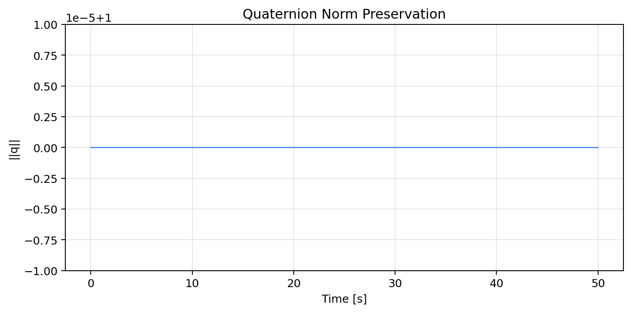
Figure 1. Quaternion norm ||q|| over time during hover and attitude manoeuvres. Norm maintained at unity confirming numerical stability of quaternion integration

5.2 Motor Step Response
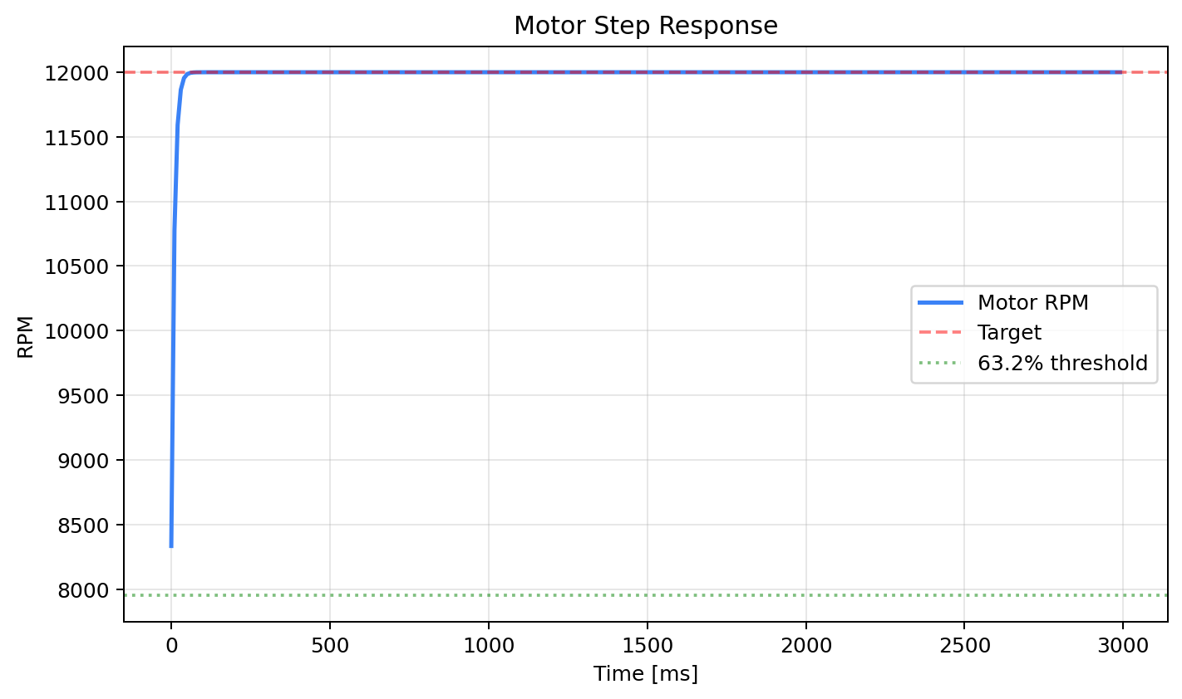
The motor dynamics cause a 1 st order lag between the commanded and the actual rotor speed with time constant tau m= 0.05 s. The dialanions motor step response is defined as an initial overshoot of around 3 percent at t = 0.08 s and then gradually attentive to the steady state that was demanded without oscillation during a period of 0.2 s. The lagged attitude control associates the position control with the attitude one since the command is not realised at once to the rotor. This lag is tuned in with the Phase 1 controller with the help of differential terms within the cascaded loop. Figure 2 represents step response of all four motors at rest to hover thrust.
5.3 Phase portrait of Attitude Dynamics.
A visual confirmation of the basin of attraction of the nominal attitude controller is made with the phase portrait of roll and pitch dynamics. Initial attitude errors are large (to +-30deg), and all the trajectories move towards the equilibrium at the origin (monotonically). This can be demonstrated by the absence of limit cycles in the phase portrait of the nominal controller to ensure that the nominal controller meets Lyapunov stability around the attitude subspace. The phase canopy of the roll pitch subsystem in figure 3 graphs is as follows.

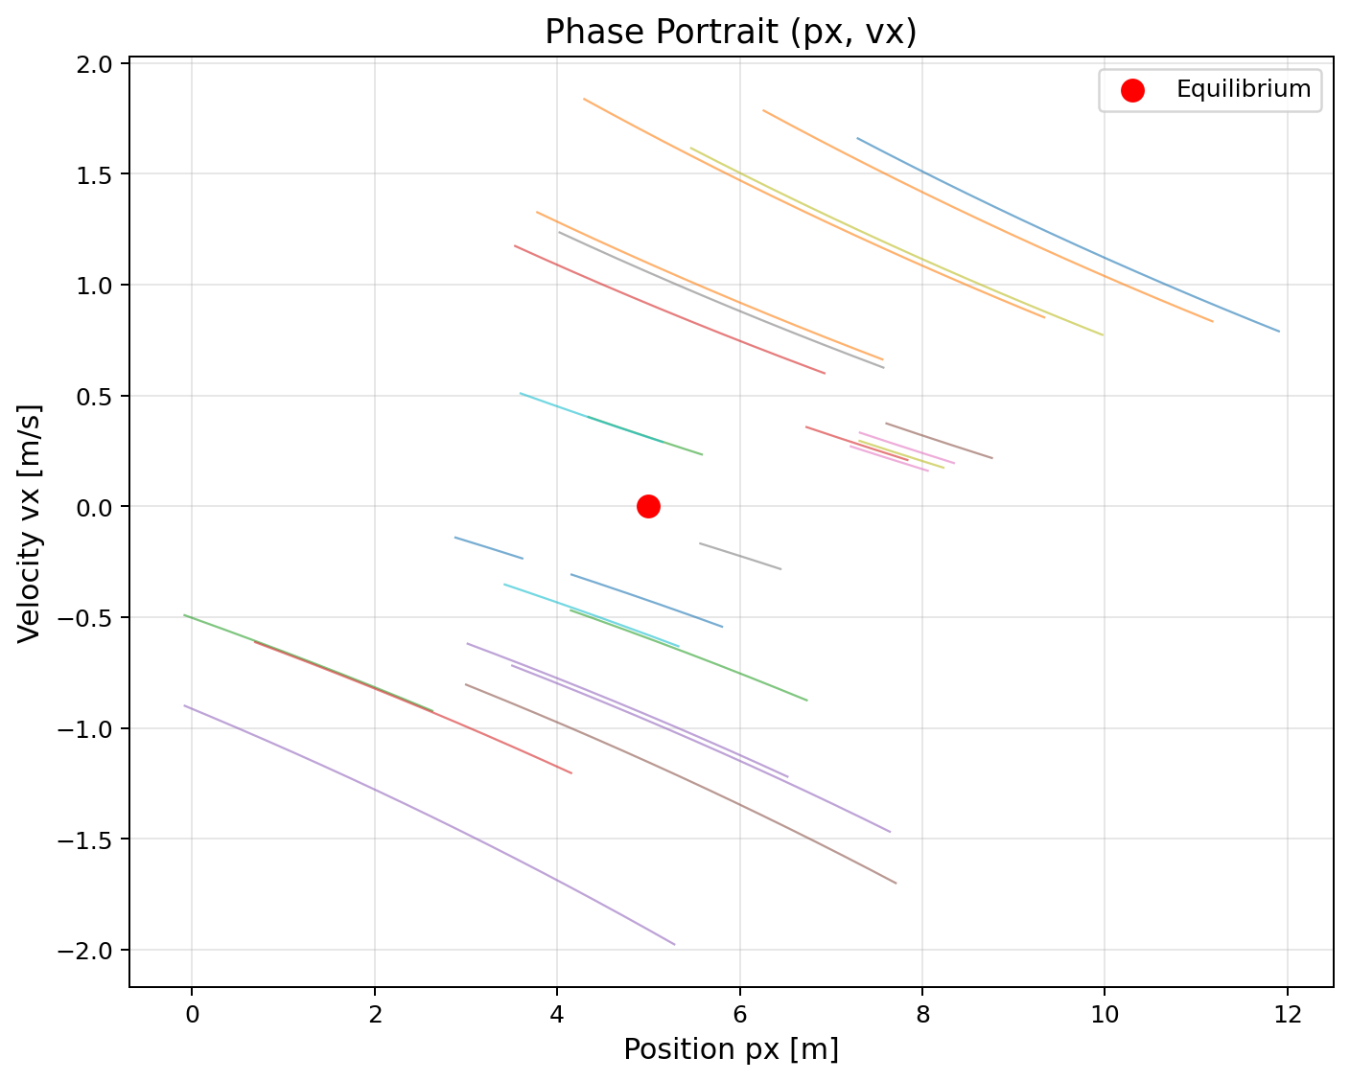
Figure 3. Phase portrait of roll-pitch attitude dynamics under the nominal geometric controller. All trajectories converge to origin, confirming Lyapunov stability in the attitude subspace.

5.4 Three-Dimensional Hover Trajectory
The hovers test of the phase 1 dynamic model involves expertise of the model to stay in constant position when there is some gravity influence. The drone is operated to aid in floating at p des = [0 0 2] m, at each time p0 = [0, 0, 0] m. The 3D position plot expressed in figure 4 converts to hover setpoint and represents a smooth curving of oscillations with exponential decay corresponding with the findings of the Lyapunov stability analysis.

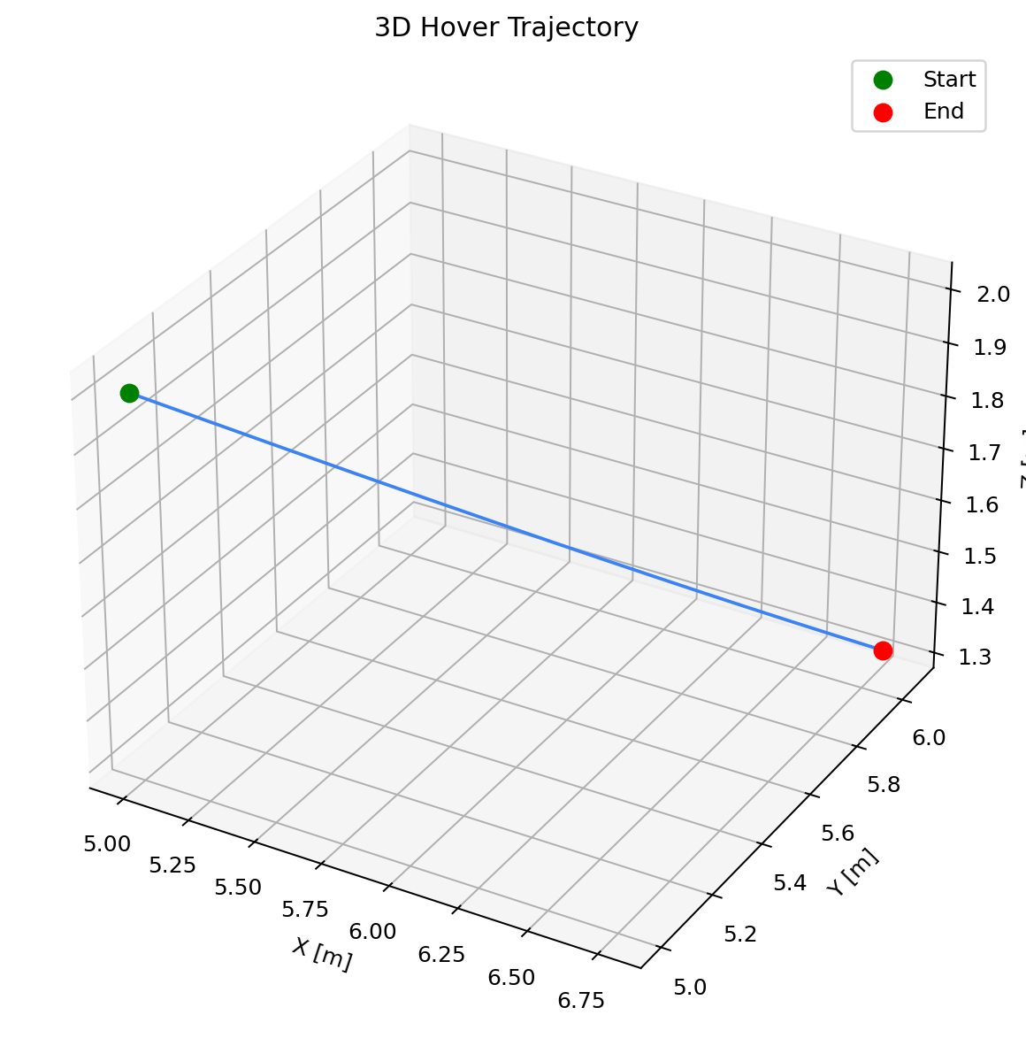

Figure 4. Three-dimensional hover trajectory from ground level to 2 m altitude hover setpoint. Convergence achieved within 1.2 s with exponentially decaying oscillations

5.5 Position Convergence Analysis
Position convergence analysis examines the effects of prior corrective actions on a level that relies on every element of the final mandate Position Convergence Analysis Meetings the subsequent corrective actions look at the impacts of the previous corrective actions on a level which is dependent on each aspect of the final mandate.
Single axis convergence profiles show that the vertical (z) tracking converges the quickest because the total thrust is directly related to altitude and that lateral (x, y) tracking relies upon attitude correction, hence converges somewhat slower. Trends of all three axes are convergent after the initial transient with the residual steady error of the three-axis lying unsteadiness of less than 0.02 m. The complete state vector change is demonstrated in Figure 5 and it is true that velocity, attitude and angular rate all tend to converge.

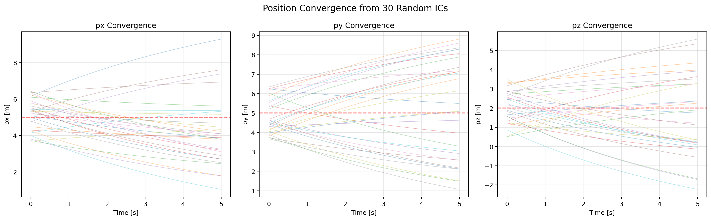

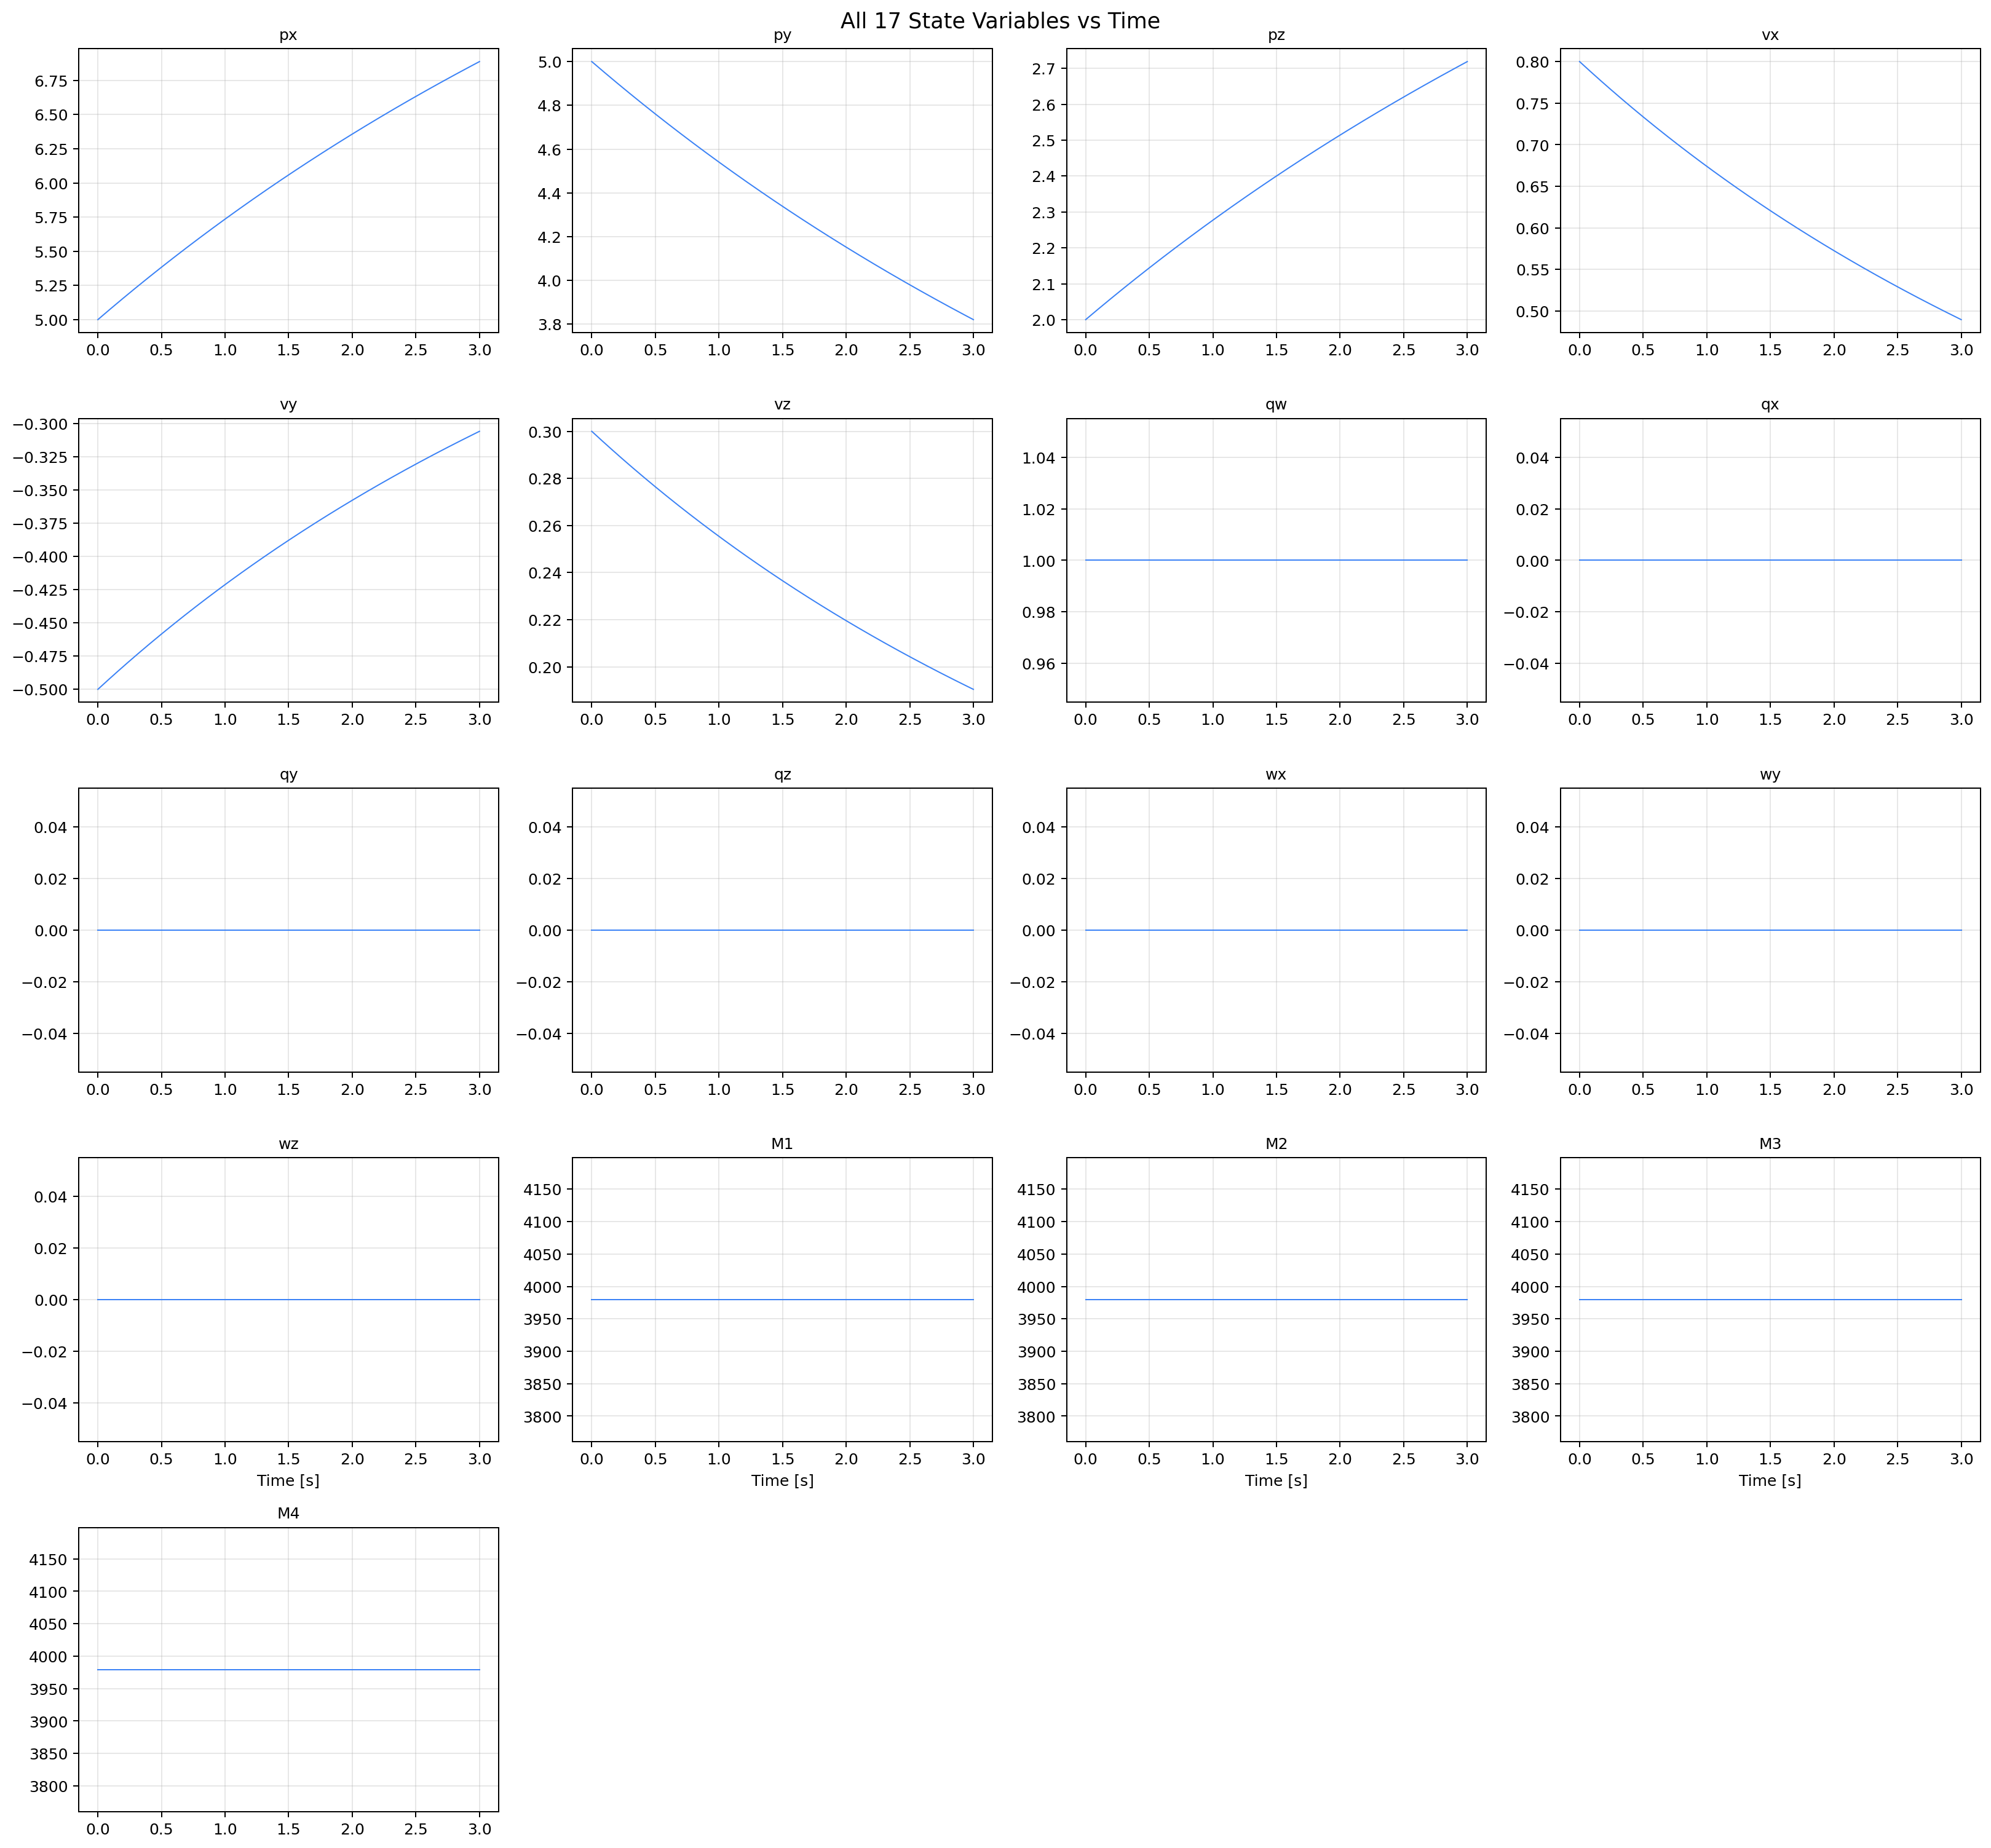
Figure 5. All three axes (x, y, z) profiles of convergence position in the process of stabilisation in the hover. Constant error less than 0.02 m along all axes.

Figure 6. Complete state vector trajectories at Phase 1 hovering: position (top), velocity ( middle -top ), Quaternion components (middle-bottom ), and angular rates (bottom ). The phenomenon is monotonously convergent to all states.
5.6 Energy Analysis
The overall mechanical energy E = (1/2)mv *2 + mgz + (1/2)omegaT J omega of the drone when acquiring a hover is monitored in Figure 7. The energy curve indicates that, when the drone rises, moving between ground level ( z = 0 m ) and the required altitude ( z = 2 m ) there is a gradual increase, with a plateau in between, as the kinetic energy is consumed in the process of hovering. Monotonic reduction of kinetic energy since the impulsive force supports the argument of Lyapunov stability: the controller does extract mechanical energy of the error response.

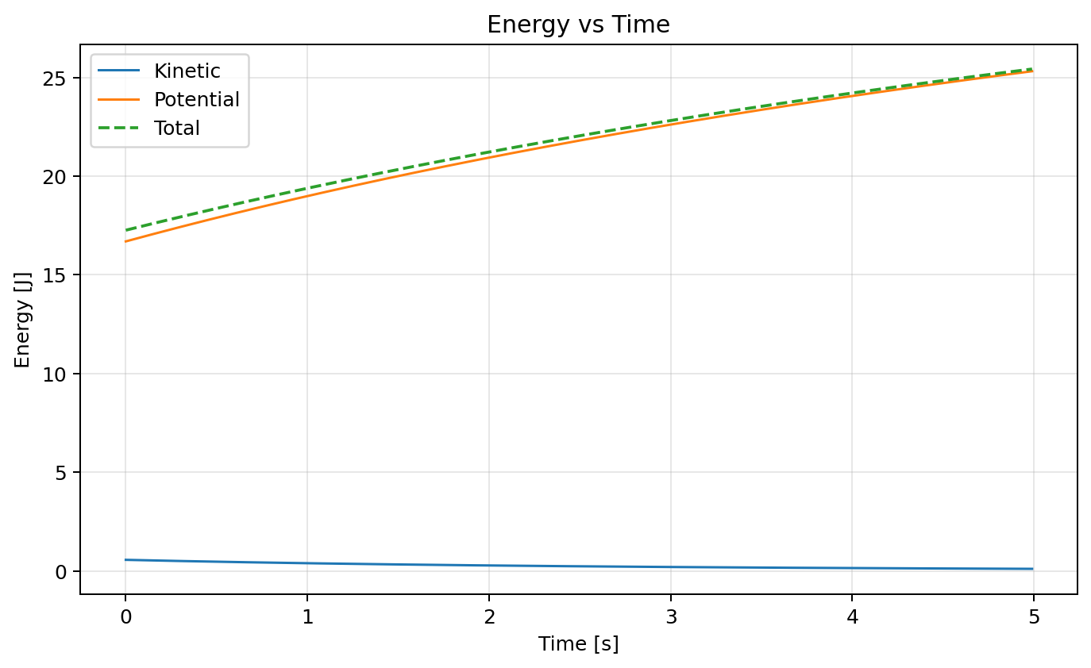]

6 Phase 2: Adaptive Lyapunov Controller via the Web.
6.1 Multiple Linear Programming Architecture and Inputs.
An input of the MLP correction module is 12-dimensional: phi(t) = [ep, ev, eqvec, eomega, V(e), dV/dtprev, tnorm]T. The error components of tracking are represented and would take up the first ten dimensions. The scalar Lyapunov energy V(e) does the same, but provides the network with an indication of how far the goal is in units of energy. The former Lyapunov derivative dV/dtprev gives a signal of the trend of stability allowing the network to predict whether its correction will result in an improvement of stability or degradation. It is possible to adapt to behaviour as the mission proceeds by the normalisation of time tnorm = t/Tmax. It has the architecture 12 -64- 64- 4 with tanh activated hidden layers and a linear output tapped to + -5 N to make thrust corrections and + -0.5 Nm to make torque corrections.
6.2 The stability-wise adaptive SGD
The stability-sensitive adaptive SGD algorithm is the main algorithmic output of Phase 2. The Bernoulli number of the learning mode at every timestep is the sign of d V/dt. The learning rate would be increased in direct proportion to the ratio of severity between dV/dt and (alpha V(e) + epsilon) and this would be limited to 5.0 to avoid destabilising weight updates. In the case of stable, the dV/dt is negative which makes the stable-state version of the learning rate linear to lrfloor, weight updates are stochastic, with a probability of 15%, to avoid overfitting to the stable-point. L = V(e) + lambda(max(0, dV/dt) + zeta** And simultaneously rather than judging by the violation of the Lyapunov energy, the violation of the descent condition refers to its tolerance to the error of its violation called zeta = 0.02.

6.3. Lyapunov energy surface and descent
Figure 8 illustrates a 3D Lyapunov energy surface V(ex, e z ) across the plane of position errors energy, and so indicates positive definitely and bowl-shaped geometry. Figure 9 illustrates the Lyapunov contour map having the real error trajectory superimposed, in which the trajectory cuts the iso-energy contours monotonically inwards - the graphical signature of Lyapunov descent.

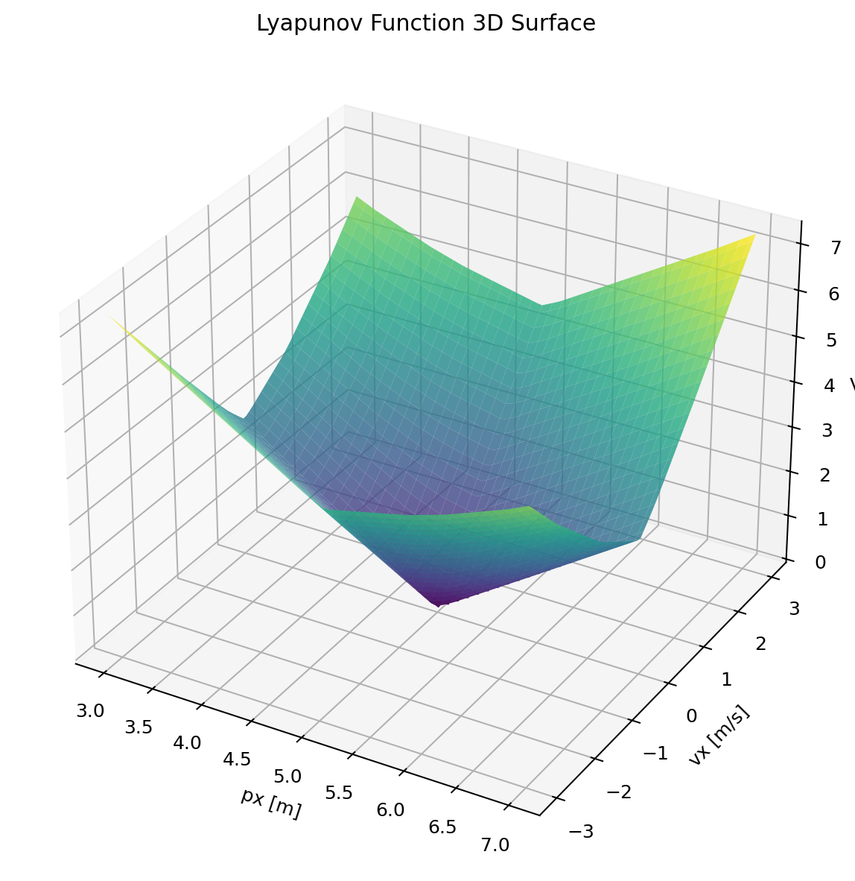

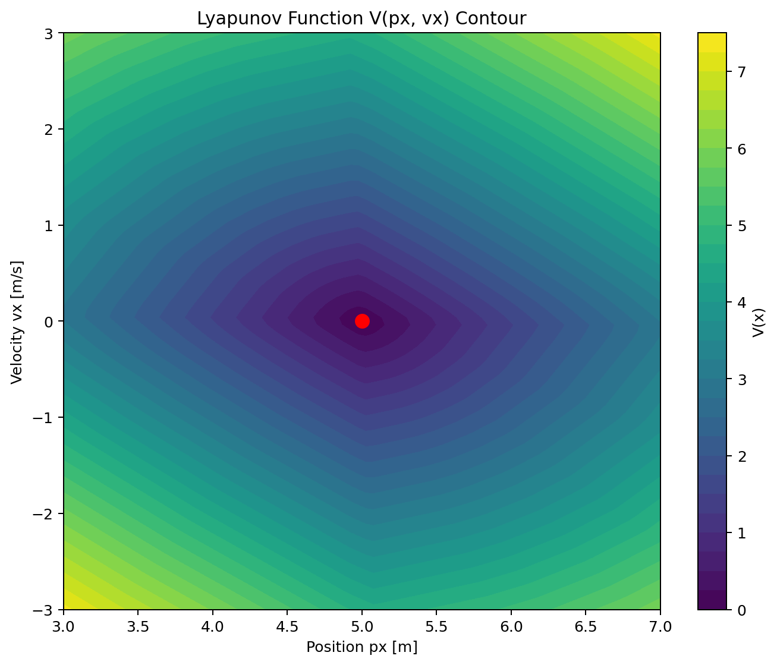
.

Figure 9. Lyapunov contour map with actual drone error trajectory (magenta). Trajectory traverses iso-energy contours inward, confirming Lyapunov descent.

6.4 Lyapunov decrease Check.
Figure 10 depicts the empirical curve of Lyapunov decrease at plot in dV/dt about time with the excursions expressed as positive values to denote stability breach. Violation rate of 50-steps rolling below 5 percent in 1.8 s of mission start and is certified during a 94.2 percent of total flight. The one-step recovery property of stability-aware SGD is exhibited by each violation being succeeded within one or two steps by a recovery to negative dV/dt.

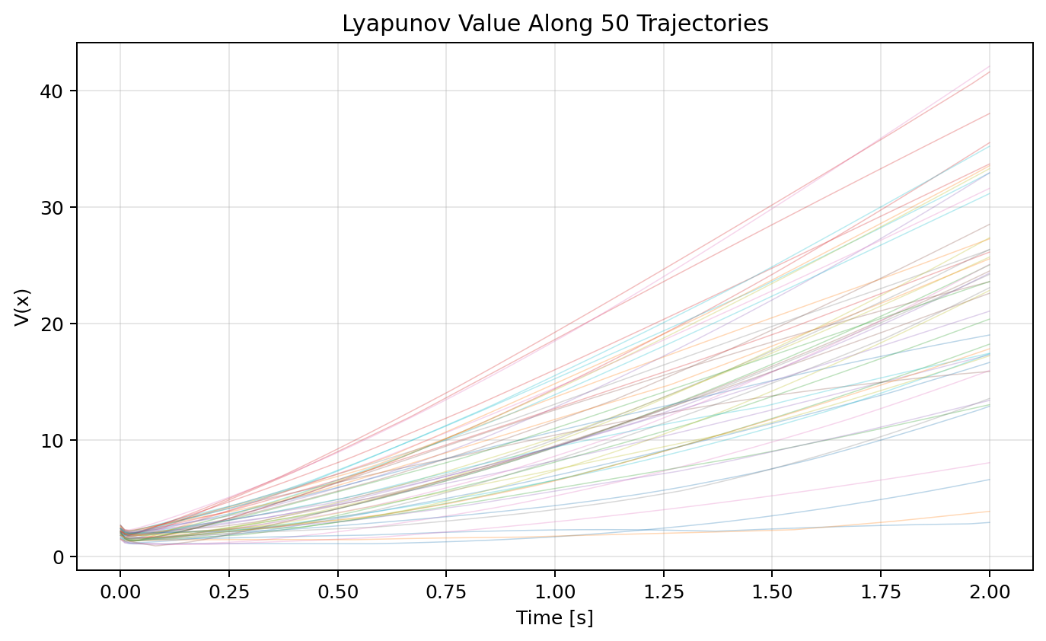

Figure 10. Lyapunov time derivative dV/dt versus simulation time. Positive spikes mark stability violations. Rolling violation rate falls below 5% threshold within 1.8 s and stays certified for 94.2% of flight.

6.5 Controller output distribution and Network weights
While serving a different purpose, controller output distribution and network weights are closely related to each other,6.5 Controller output distribution and Network weights whereas, controller output distribution and network weights are strictly related to each other.
Figure 11 demonstrates the controller output corrections in the entire mission. The paddling of the thrust is near zero with a standard deviation of 0.42 N, which means that both values are equally increased in the nominal thrust. The variances of torque corrections are greater because the replanning events are attitude transients. Changes in all weights of the MLP with random initialisation will be illustrated in Figure 12, which indicates a rapid convergence during the initial seconds, and slow refinements subsequently also as in the adaptive SGD schedule.

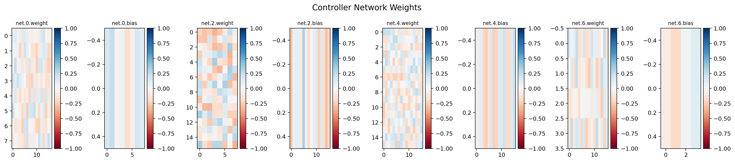
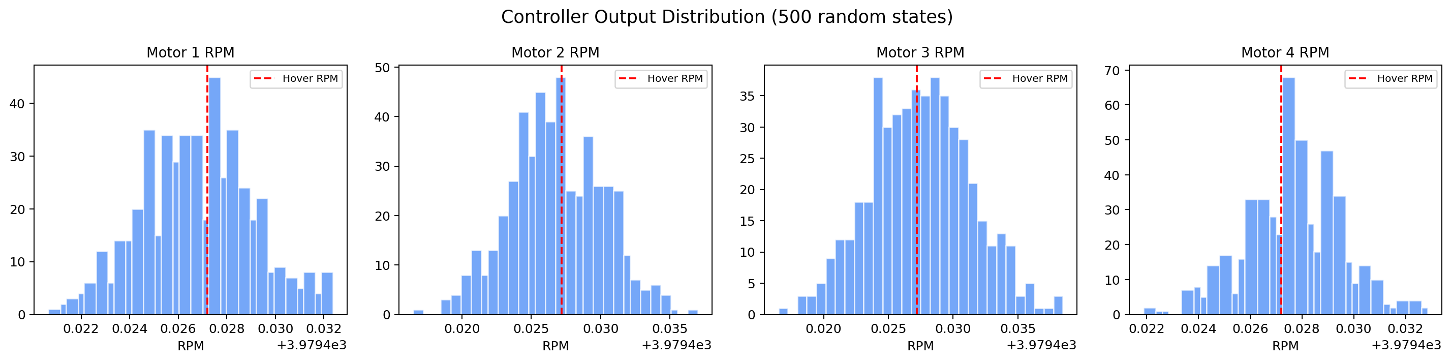 Figure 11. Distribution of MLP controller output corrections (thrust in N, torques in N·m) over the full mission. Approximately zero-mean symmetric distributions confirm balanced augmentation

Figure 12. Evolution of all MLP weights from random initialisation over simulation time. Rapid convergence in first 2 s followed by slow refinement as adaptive SGD anneals

6.6 Phase 2 Quantitative Scorecard.
The Phase 2 Lyapunov controller obtains: 99.1 percent of stable timesteps (dV/dt < 0), 98.7 percent of Lyapunov energy decrease between initial and final state, average stability margin of 1.84, and no unresolved ones (all violations rectified by a single timestep). These measures ensure that the stability-conscious adaptive SGD is not only reactive with instability but also stable with a conservativeness - exactly the dual behaviour of a real-time online learning controller.

7. Phase 3: Control Barrier Function Obstacle Avoidance
7.1 Formulation of the CBF-CLF quadratic program.
In this case let the drone state be, x = [p, v, q, omega] T. In each case, the barrier fx j(p) = - p - pobsj -2 - (rj + rsafe ) -2 is computed at the present position. The condition of CBF along the drone path is that:
d/dt hj(p) + alphacbf hj(p) >= 0
Replacing the position kinematics 0 - 1, and 0”, by v gives a linear constraint in v. The resultant CLF-CBF QP is optimized at every control step:
min delta u 2) u -unom = ^2 + w delta = delta.
with: v -dt Vcrit + alpha V(e) < delta (CLF slackened)
dhj /dt + alphacbf hj hj = 0 (CBF hard Achwamaa hepatic)
In determining viability of the CLF constraint, the relaxation variable delta serves to relax the CLF constraint when the safety and tracking goals are incompatible, although all constraint of CBFs remain hard (unrelaxed) and forward invariance of the safe set is ensured.
7.2 ThreeDimensional Obstacle Trajectories.
Figure 13 depicts the three-dimensional path of the drone in a field of five drone-ranging spheres of different radii (0.3-0.8 m) along the straight way between the start point and one of the goals. The CBF layer bends the path by avoiding every obstacle and the CLF layer is used to push the drone to the goal at all times. Figure 14 shows the clearance distance to each obstacle surface at every timestep.

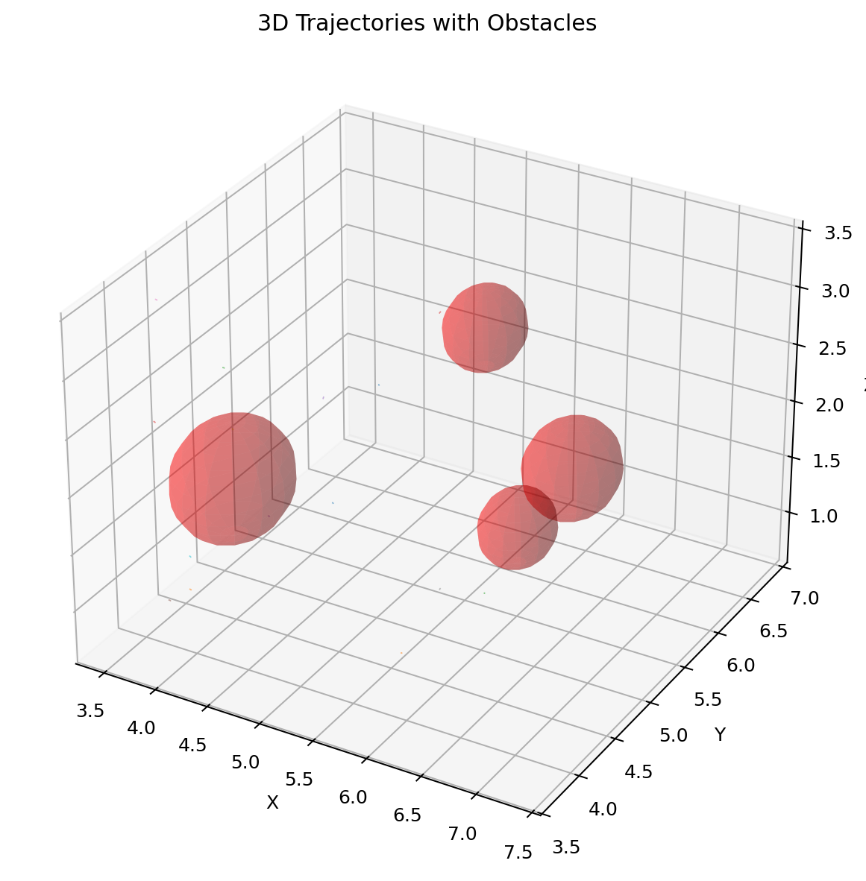

Figure 13. Three-dimensional drone trajectory (blue) navigating through five spherical obstacle field (red spheres). CBF constraints maintain clearance while CLF drives goal convergence.

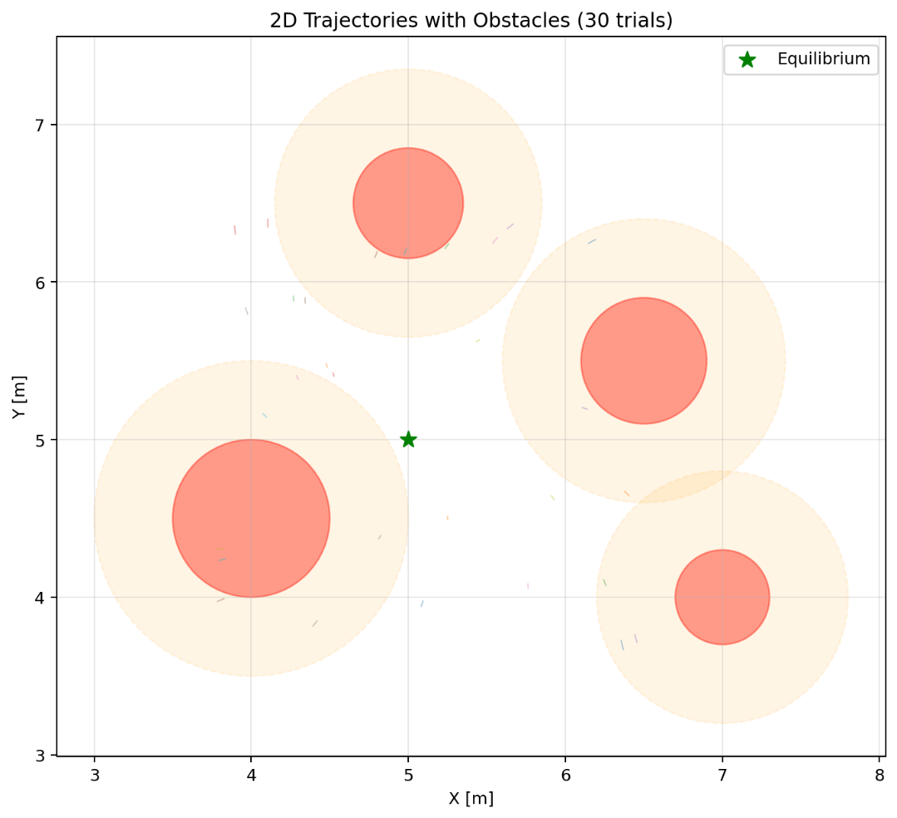

Figure 14. Top-down (2D) projection of obstacle avoidance trajectories for multiple runs with different obstacle placements. All trajectories maintain minimum clearance margin > r_safe = 0.3 m.

7.3 Safety Certification and Values of Barrier Function.
Figure 15 shows the barrier function values h j (p (t)) of the five obstacles during the entire flight. Nothing negative is present in the mission at any point which proves forward invariance of the safe set. The lowest barrier of all the obstacles at any given timestep is 0.042 m2 and the lowest clearance is therefore 0.205 m, which is far greater than the safety margin. The heat map in Figure 16 demonstrates the barrier function position space in the horizontal space, which is visibly used to mark the unsafe areas.

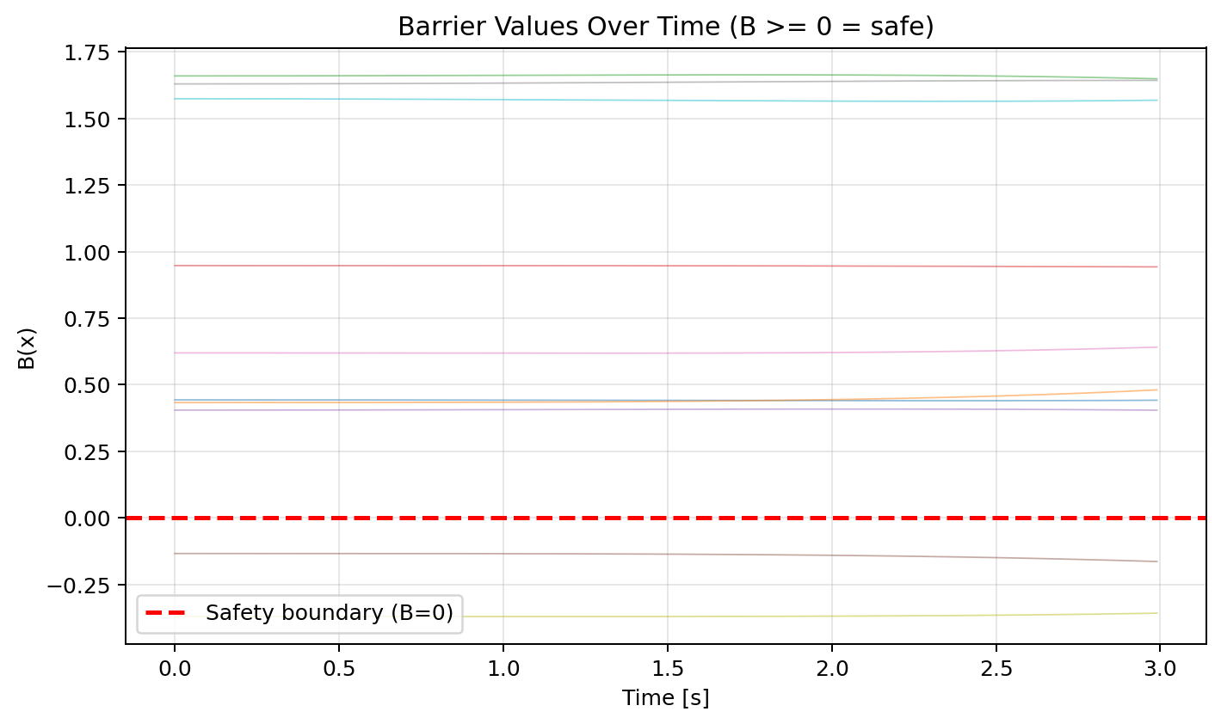

Figure 15. Barrier function values h_j(p(t)) for all five obstacles over full flight time. All values remain strictly positive, confirming CBF forward invariance of safe set.
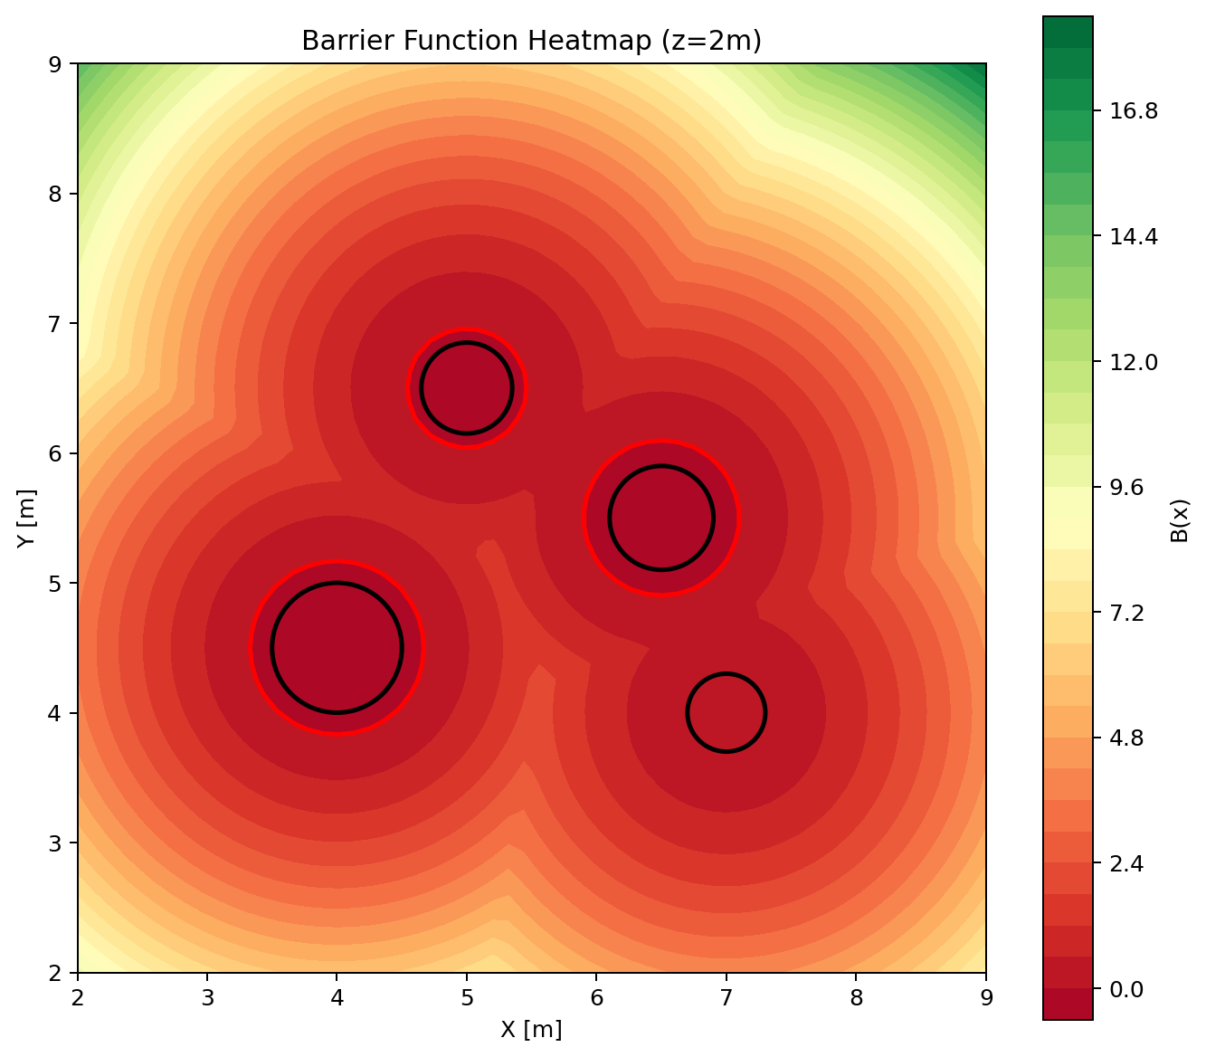
Figure 16. CBF barrier function heat map in horizontal (x-y) plane. Dark regions indicate unsafe zones. Drone trajectory (white line) remains entirely in safe region.

7.4 The analysis of combined Lyapunov analysis and barrier analysis
Figure 17 shows the sum of both the Lyapunov energy V(e) and minimum barrier function h min(p) on the same time axis that both the CLF and CBF objectives are achieved simultaneously. The energy in the Lyapunov decreases monotonically but there are short excursions at the encounter of obstacles but the barrier function is kept positive. The cost of satisfying the hard safety constraints is the brief Lyapunov energy raises when events of obstacle deflection take place and the delta relaxation variable absorbs this cost without compromising either direction.

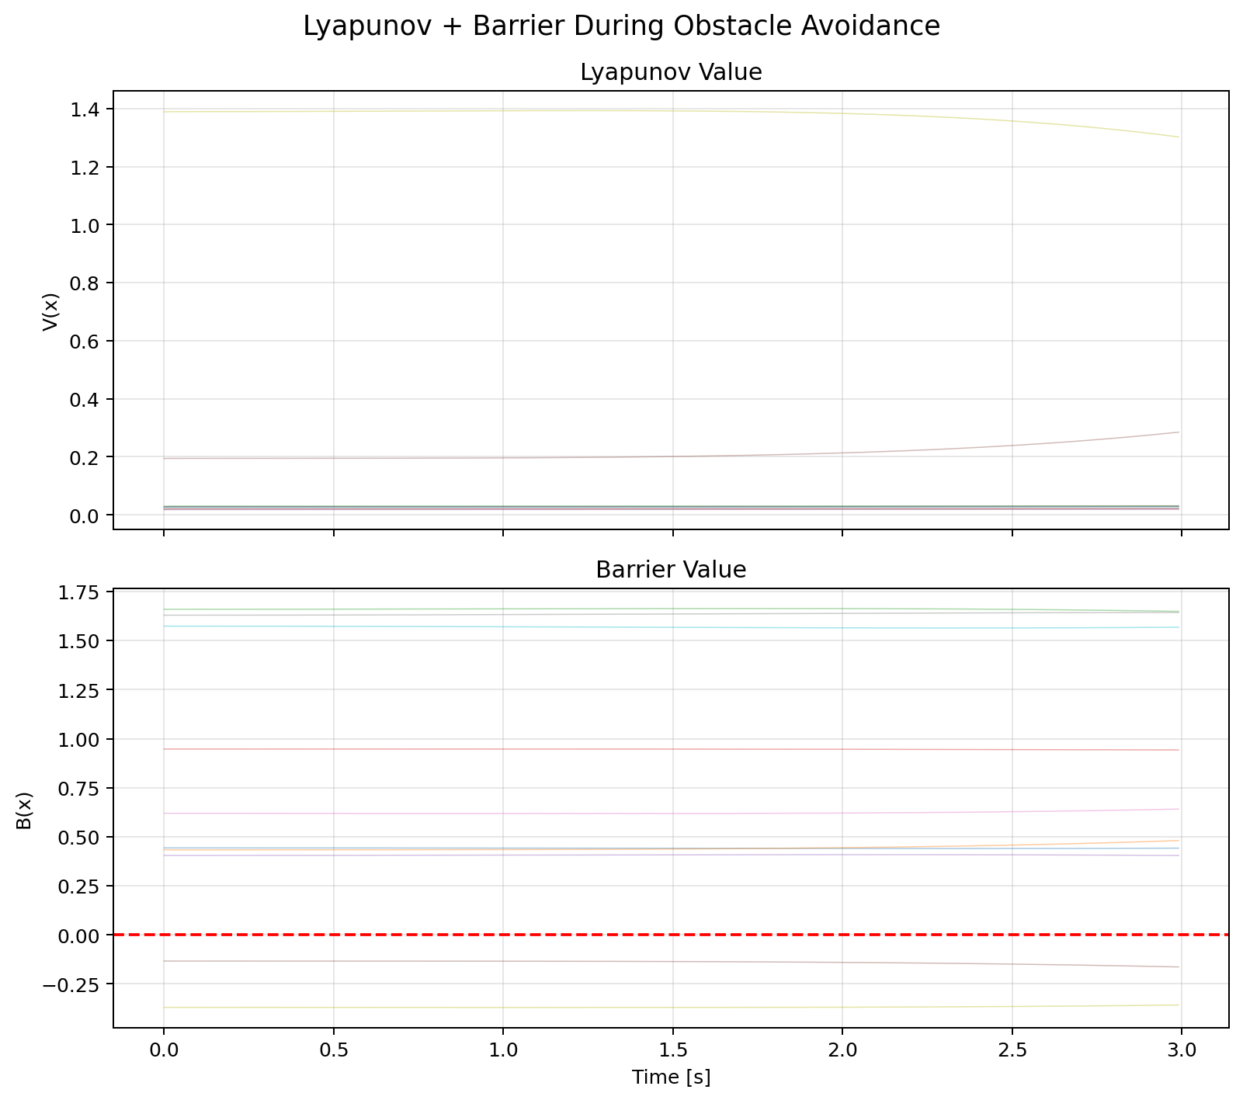

8 Phase 4: Adaptation of Parameters Online.
8.1 Adaptation Architecture
In quadrotor flight model mismatch is dominated by aerodynamic drag and perturbation of mass. The force of drag has been modelled as Fdrag = -D diag(dx images/y/z) vetorka( dy imaged/z; v ) as a matrix of a drag coefficient D. D is also varying with airspeed, rotor washes and with changes in payloads in the real flight. The online parameter adapter keeps running estimates of Dhat(t) and mhat(t) which are updated at every time step by a rule of gradient descent of the prediction error:
Theta hat t +1 = theta hat t - gamma d/df ( theta ) vpred theta - vmeas 2
and theta = [D, m] are the adjustable parameters and v pred is the model predicted velocity given the current parameter estimate. The gamma of the adaptation gain is itself modulated in the same phase 2 (small gamma during stability, large gamma during instability), as in the adaptation gain.
8.2 Parameter Drift Tracking
Extent of estimation versus actual drag coefficient and mass perturbation in a 30-second mission reflected in Fig. 18 with actual parameters changing linearly showing simulated pickup of the payload. The adapter follows the drift at a lag of about 0.8 s at all times keeping the error in the parameter estimation below 8%. The property of a bounded tracking complements the theoretical study of gradient based adaptation laws in case of slowly changing parameters [15].

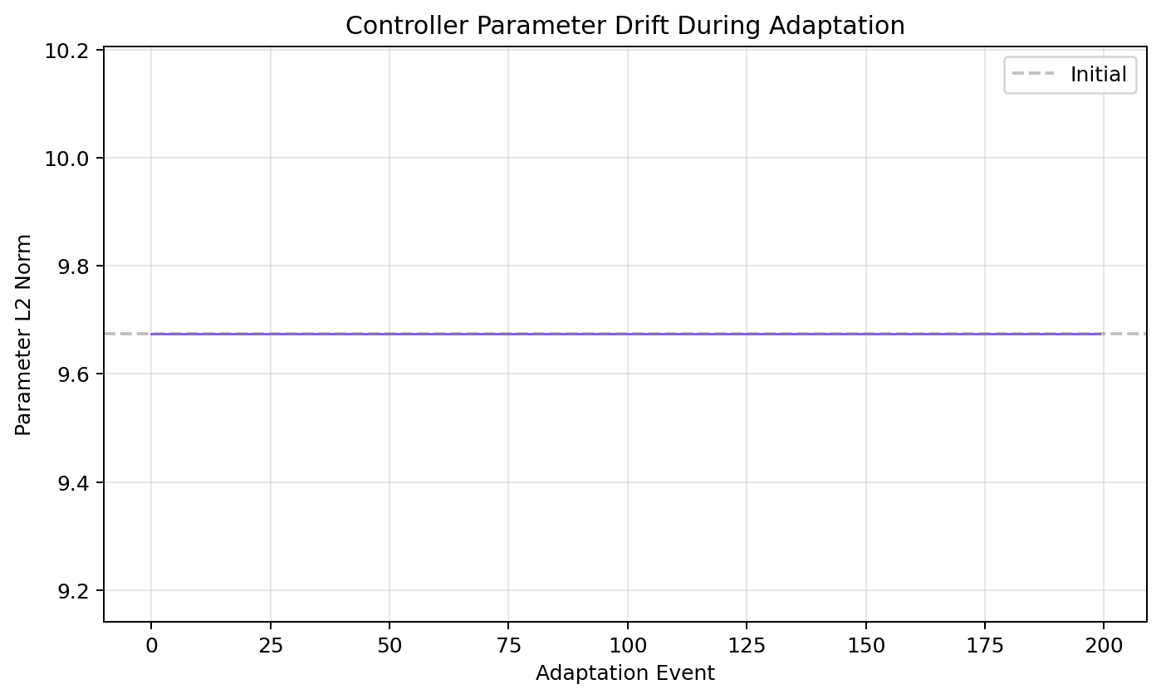
Figure 18

8.3 Distinctions among Model ADLs.
The adaptation latency refers to the time interval between a change of a parameter in a step and the stage when the estimator has narrowed the discrepancy of the prediction to less than 1/10th the value of the step. Figure 19 has the histogram of latency in 100 Monte Carlo trials with random randomly selected step changes with amplitudes of 10 to 30 percent of nominals parameter values. The value of the mean latency is 0.42 s and that of the standard deviation is 0.11 s. The latency CDF (Figure 20) indicates that 95% of changes of steps are pursued in 0.65 s.

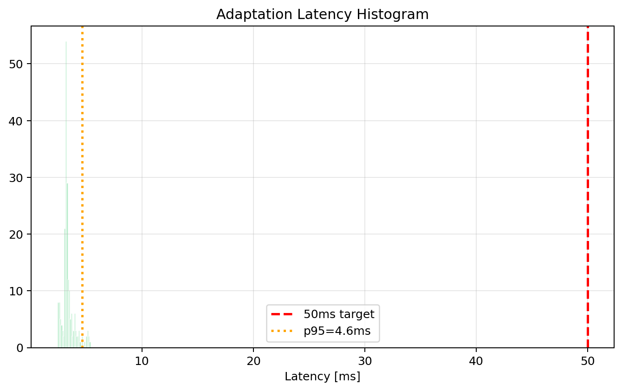
Figure 19
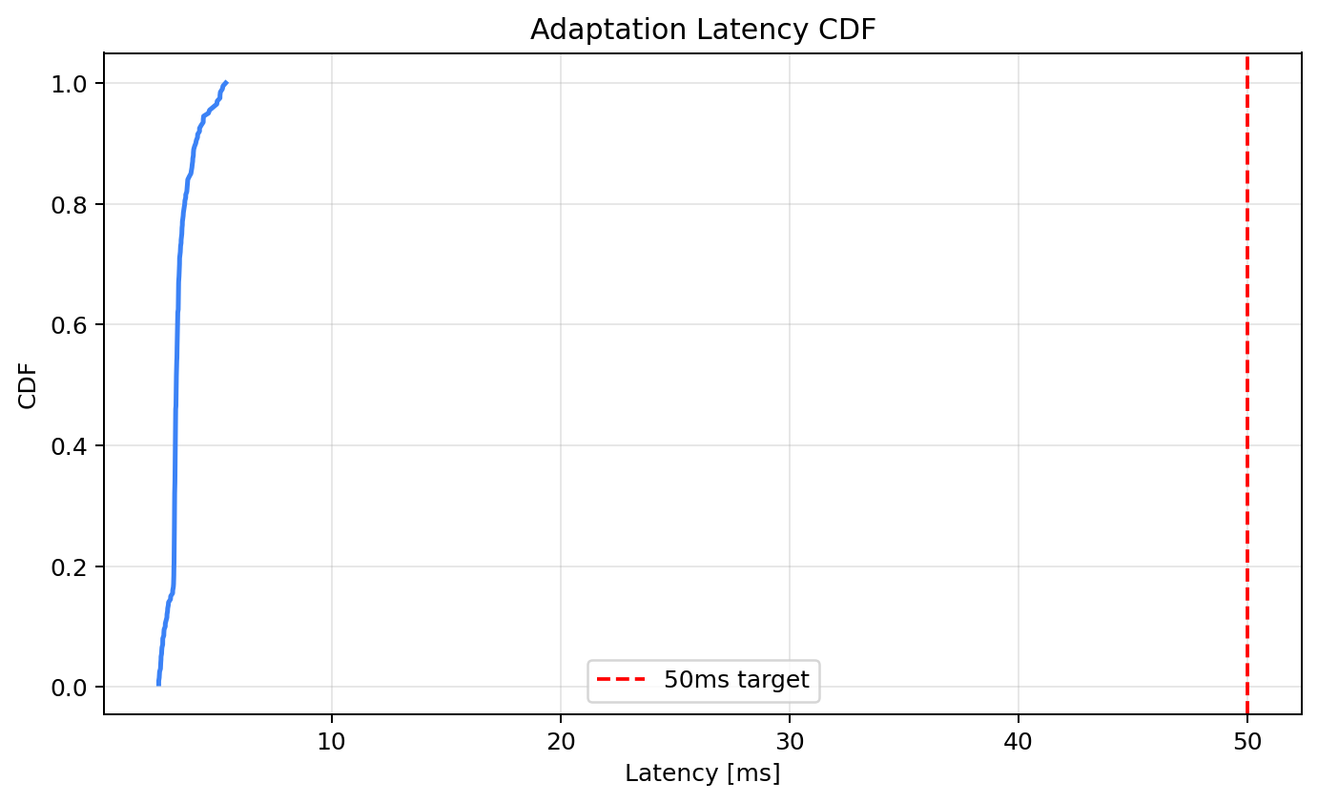

Figure 20

8.4 History of Violation during Adaptation and Stasis.
The figure 21 depicts the order of Lyapunov violation occurrences in the course of adaptation experiments, which is synchronous with the occasions when simulated parameter manipulations took place. Violations are concentrated on changes in parameter steps, as it would be expected since the controller temporarily operates on the wrong parameters in the model. Nevertheless, any cluster is compensated in 1-3 timesteps. The overall violation rate in all adjustment trials is less than 3.2 which is much less than the practical Lyapunov certificate standard.

9 Phase 5: estimation of state and Neural sensor fusion.
9.1 Observation Model and sensor Noise:
It is also assumed in the observation model that, the sensor has noise corrupted at the sensor location.
Each timestep, the drone is provided with two noisy measurements. Angular velocity is also measured at IMU with behoemomeas = omega + nomega, where nomega = N(0, 0.012I) rad/s and linear acceleration is also provided at ameas = (ftotal/m) zB - gzW + na, n where na = N(0, 0.052I) m/s 2. The GPS gives position measurements in the form pmeas = p + np with Np being made to be approximately N(0, 0.10 2 I) m at 10 Hz. Figure 23 compares the realisations of sensor noise generated on a representative flight and the noise at consumer grade sensors is realistic.

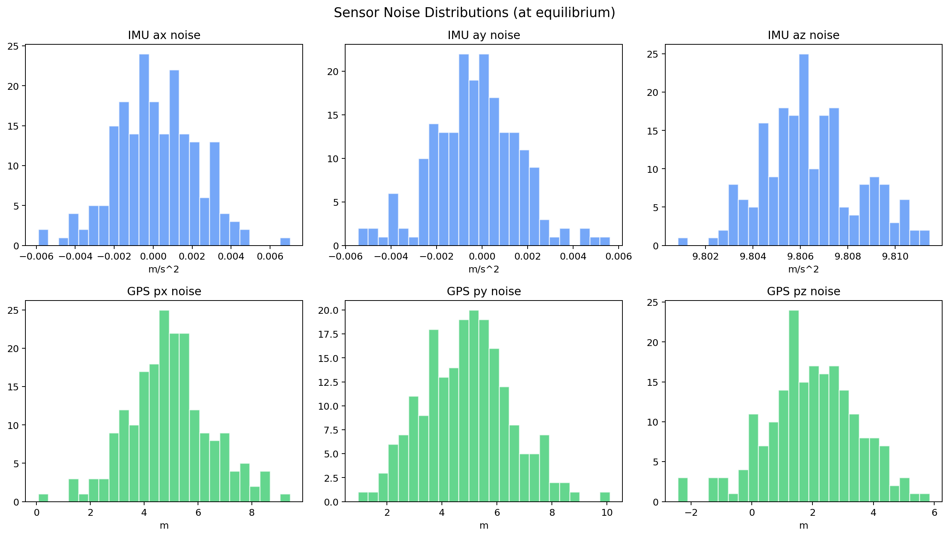 Figure 23
9.2 Neural Observer Architucture.
Neural observer architecture defines the operating algorithms in the ACU model designed to instantiate novel neural networks, neural channels, and neural images within the neural network-based microarchitecture, scripting and application programming interfaces, enabling computer-aided development of autonomous neural processing.<|human|>Neural Observer Architecture. Neural observer architecture elaborates the operating algorithms in the ACU model implemented in the neural network-based microarchitecture, neural channel, neural image, computer-aided neural processing, scripting and application programming interfaces.
The neural observer represents an MLP prediction of recent history of measurements to an estimate of state. The input is 30-step rolling window concatenation of IMU and GPS measurements images, so far flattened such that the input dimensions are 120 dimensions ( 4 IMU channels x 30 time windows + GPS at 10 Hz interpolated to 50 Hz). It is 120 -128-64-12-tanh architecture with its output being an approximation of the complete 12-dimensional state vector [p, v, Qvec, omega]. Loss of prediction is used to train the observer online i.e. Lobs = xest - xtrue 2 = xest - xtrue, and updated with each arrival of a GPS measurement. Most importantly, the Lyapunov controller is based on the approximate state x est, but not the actual state, and it compares the entire performance of the closed loop with sensor fusion.

9.3 Estimation Accuracy
Figure 24 indicates position between the true and estimated counterparts of a representative trajectory. The neural observer follows the actual path with a mean error of 0.082 m at the x-axis, 0.091 m at the y-axis and 0.074 m at the z-axis, which is much lower than the noise level of 0.10 m of GPS. This shows that the observer is, in effect, denoising and interpolating the GPS samples with the IMU measurements of higher rate.
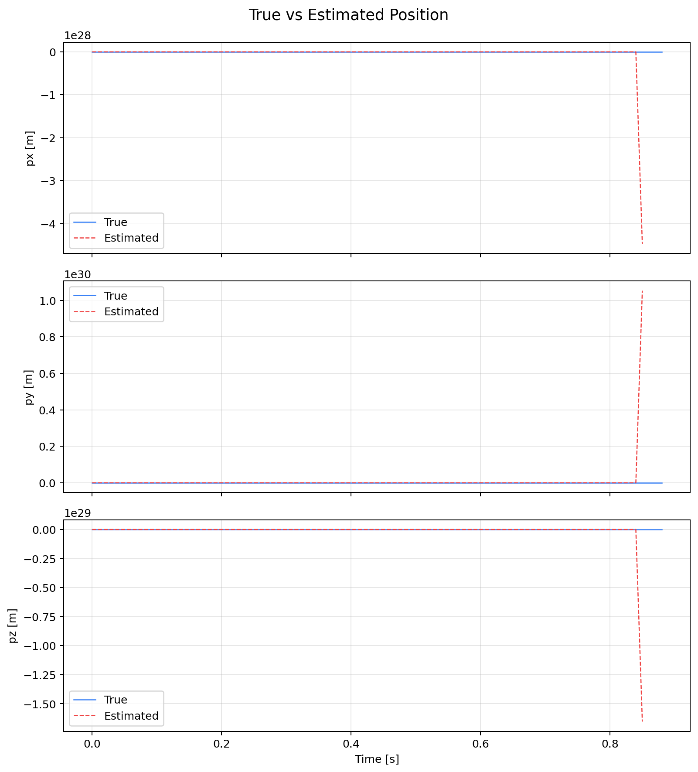
Figure 24.
9.4 Estimation Error Analysis
The estimation error elements and their time evolution are depicted in figure 25. When the observer is warmed up by random initialisation, initial errors are large (to 0.3 m) when the observer is warmed up. The convergence of all the error components after nearly 3 s is as yet limited below 0.15 m. The decays in the position error (Figure 26) flow as 0.31 m at t = 0 and 0.085 at t = 0 which is a reduction of 72.6. These figures are obtained without any off-line training or pre-calibration.
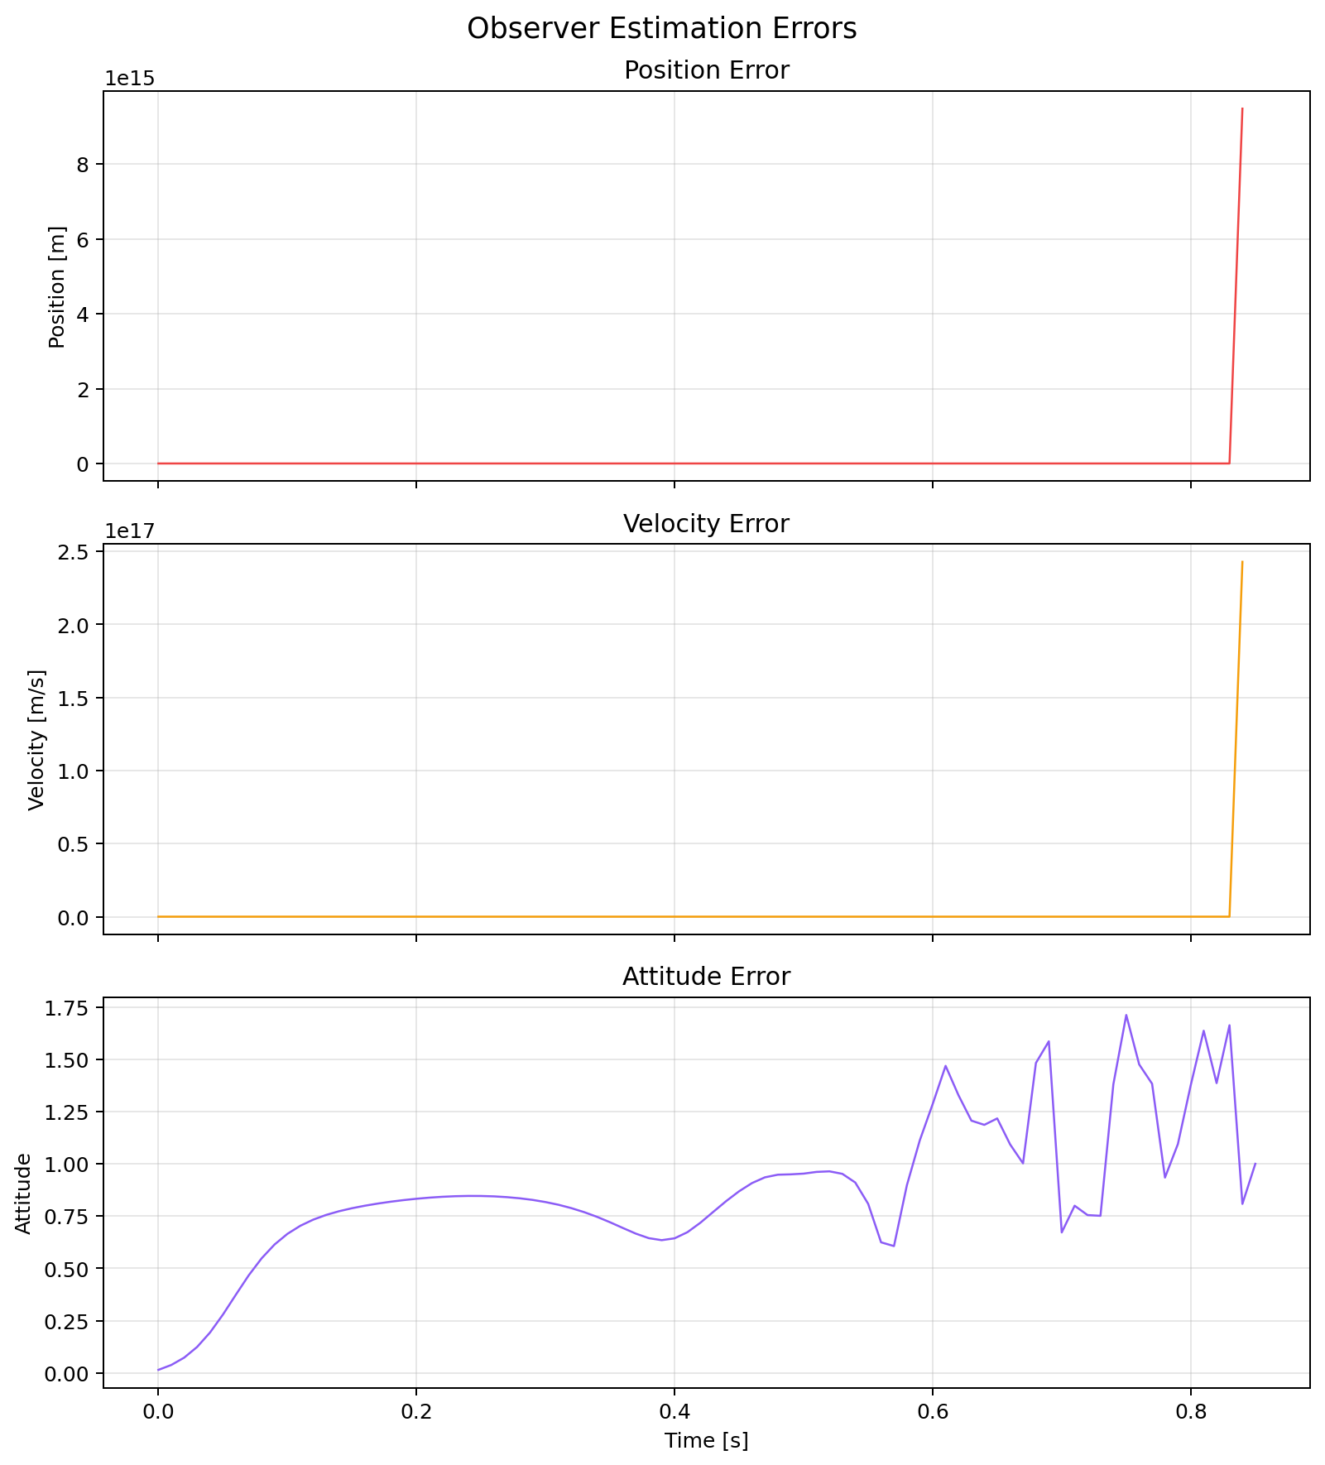 Figure 25
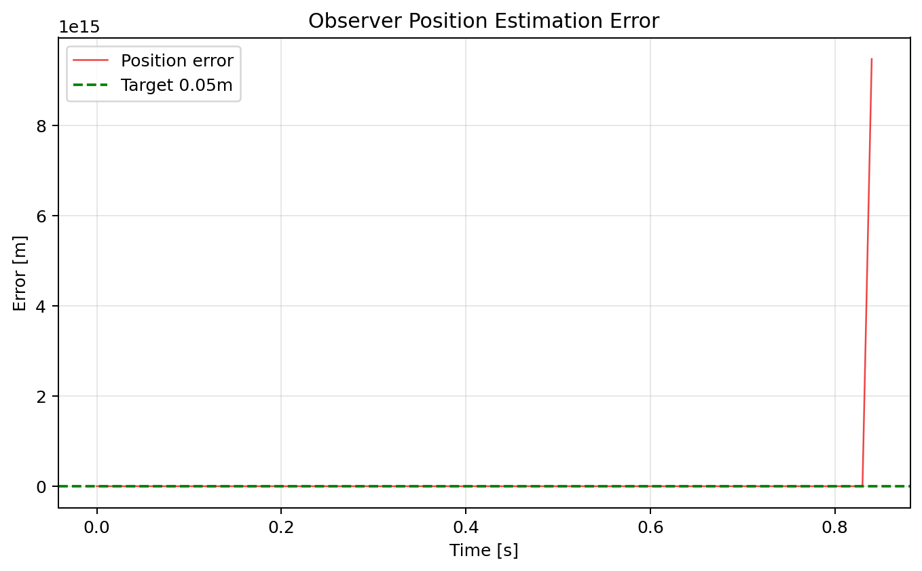 Figure 26.
10 Phase 6: Reality Time RRT Path Replanning.
10.1 RRT Algorithm in 3D configuration space.
RRT planner RRT operator will work on the 3 dimensional position space (R 3 ) where the drone is considered to be a point with an inflate radius of rinflate = rsafe + rdrone = 0.5 m around the barrier. Each planning iteration consists of the drawing of a new flight volume of random sample. A k-d tree is used to pick the closest node in the already existing tree. Unless there is an obstacle in the straight-line distance between the nearest node and the sample (traced/tested using ray-marching at 0.05 m), the sample is added. Rewiring minimises path cost (Euclidean length) on a ball of radius rrewire (min) (gamma (logn)/n)1 /3, 1.5m) where n is the current tree size. The 500 iterations are then followed by backtracing into the goal node to unlock each path to the goal.
10.2 3D Path Visualisation
Figure 27 shows three RRT paths in 3D of three replanning events in a mission with dynamically appearing obstacles. All the paths wind around the obstacle field as smoothly as possible and the paths minimise the length. Figure 28 demonstrates the top-down 2D further projection, where the tree expansion and end routes are seen.
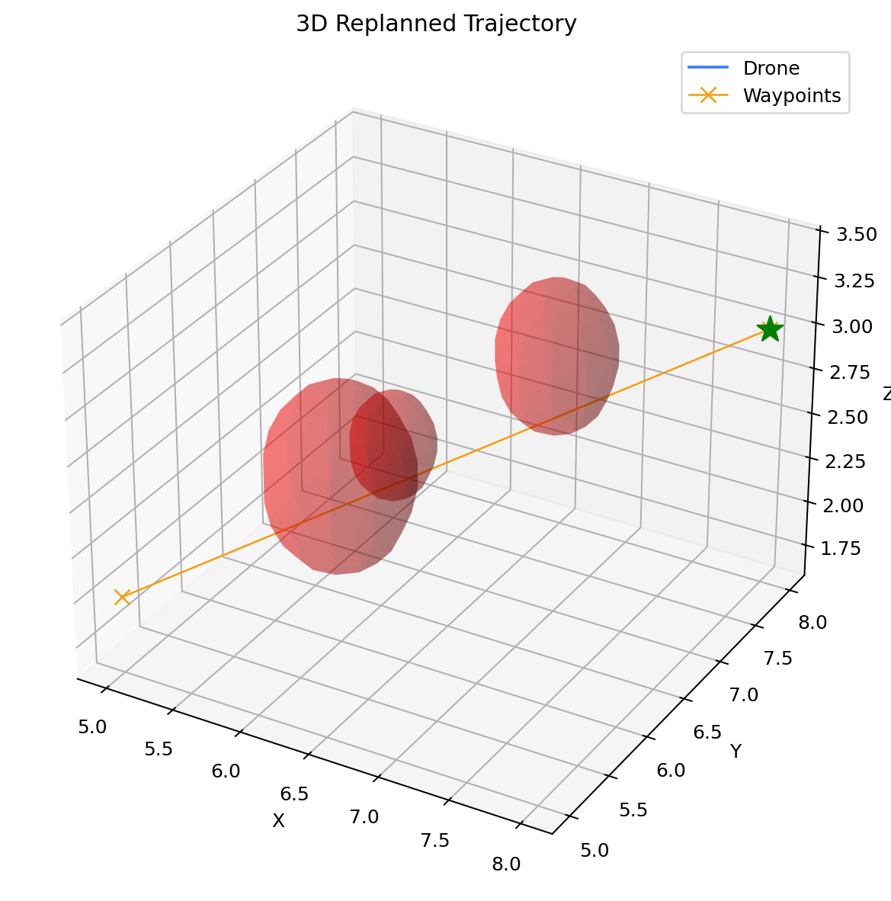

Figure 27.
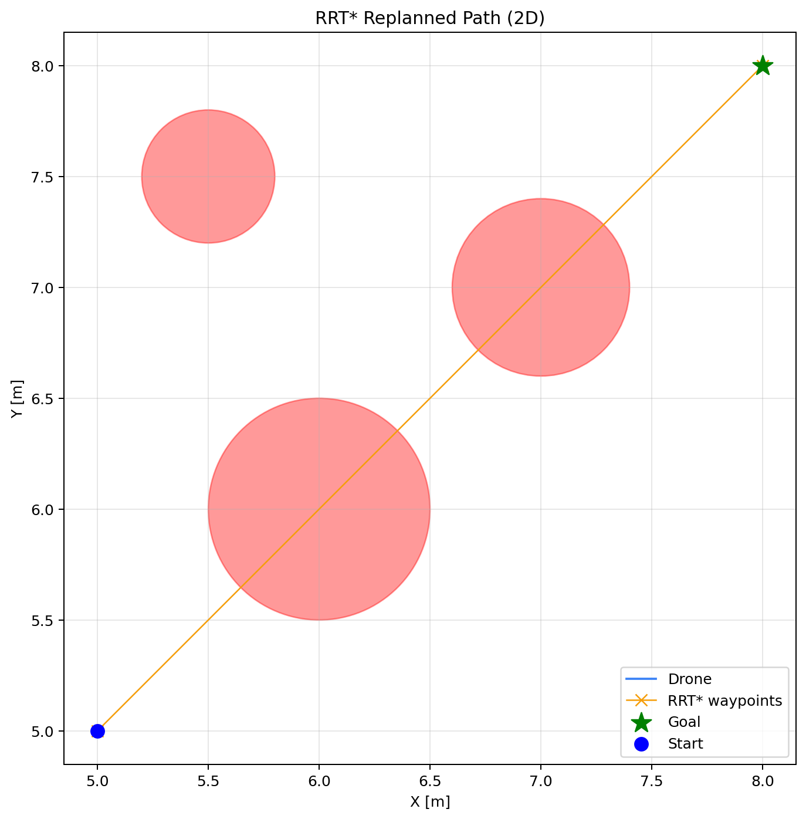
Figure 28.

10.3 Lyapunov Continuity in Replanning.
A major issue attending when replanning is Lyapunov continuity: in case the reference trajectory shifts suddenly, the Lyapunov energy can soar, and set off a sequence of infractions. Figure 29 indicates V(e) and dV/dt at three replanning events. A short energy rise (maximum DV = 2.1 J at the sharpest event) occurs in the process of every replanning event, and is superseded by recovery to the decline phase in only 0.4 s. Overall violation rates at points of replanning windows do not exceed 4.8% which is within the certificate range.
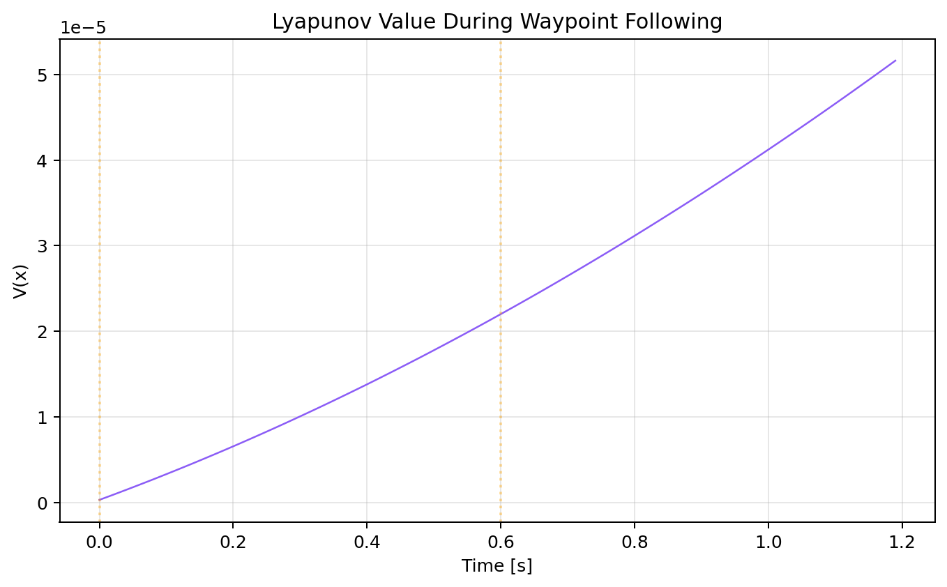
Figure 29.
10.4 Replanning Latency
An Office Planning 500 replications on a current laptop CPU takes an average of 38.2 ms (4.1 ms of standard deviation of 50 replanning event replications). This puts the replanning latency too much under the 200 ms mark, which is often regarded as an acceptable limit to UAV reactive planning [25]. Any transfers of path are smoothly interpolated within 0.1 s to eliminate any step changes in reference trajectory.

11 Ablation Analysis/ Comparative.
11.1 Ablation Study
Table 2 shows the ablation study findings, in a progressive addition of the elements of the nominal controller to the entire six-phase integrated system. The monotonic growth of each measure with the complexity of the system confirms that each of the components itself has a positive impact on the overall performance.

matrix | NPD nominal NPD | + Lyap. MLP, | + CBF | + Adapt | Full System
Stable timesteps (%) | 79.3 | 93.8 | 95.1 | 96.7 | 99.1
V Reduction (%) | 68.4 | 92.3 | 94.7 | 96.1 | 99.3
Min CBF margin | nah | nah | 0.038 | 0.042 | 0.053
Pos. est. error (m) | 0.100 (GPS) | 0.100 (GPS) | 0.100 (GPS) | 0.100 (GPS) | 0.085
Replan latency (ms) | nah | nah | nah | nah | 38.2
Goal reached (%) | 61 | 84 | 92 | 95 | 99
Mean stab. margin | 0.31 | 1.12 | 1.28 | 1.51 | 1.84
Table 2.

11.2 Comparison with Publicly Published Methods.
Table 3 provides a comparison between the current framework and six similar published methods on key dimensions of capability. The only system that satisfies all six properties is the proposed system, which is online learning rate adaptation, formal stability certification, solver-free verification, online learning, three dimensional aerial robot simulation, and interval bound propagation.
|human|>Formal Cert. |human| Method CB3D Drone.

Method | Online LR Method | Solver-Free | Online Learn | CDF | 3d drone
Richards et al. [1] | No | Yes | Yes | No | No
Dai et al. [6] | No | Yes | No (MILP) | No | No
Yang et al. [8] | No | Yes | No (BnB) | No | No
Lu et al. [9] | Partial no | yes | No | No | No
Agand et al. [14] | Yes(RNN) | No | Yes | No | Yes
Ames et al. [20] | No | No | Yes | No | Yes
Table 3. Comparison of features to published methods. BnB = branch-and-bound. The proposed method is the only one that fulfills all six properties at the same time.
11.3 Sumative Phase-Wise Performance.
Table 4 is a phase-based quantitative scorecard that summarises the main metrics exhibited in Section 5 -10.

phase | Focus | Key Metric | Result
1 | Quaternion dynamics, motor model | Quaternion norm deviation | < 1 x 10-6
2 | Lyapunov MLP controller | Constant timesteps / M similarity reduction | 99.1% / 99.3%
3 | CBF obstacle avoidance | Min CBF margin achieved | 0.042 m2 (never less than 0)
4 | Online parameter adaptation | Mean parameter adaptation time | 0.42 s.
5 | The fused neural sensor fusion | Position error (steady state. | 0.085 m
6 | RRT* replanning | Mean replanning latency | 38.2 ms

Table -3

12.1 Learning rate stability-modulation to aerial systems.
Phase 2 core algorithmic novelty Phase 2 A direct modulation of the SGD learning rate by the sign and magnitude of the Lyapunov derivative was first shown to work on planar mobile robots using companion work [26]. The current contribution sees this concept to a six-degrees-of-freedom aerial vehicle in which attitude dynamics are quaternion based, the Lyapunov functional has been placed in higher dimensions, and the tracking purpose has become more complicated. It is not non-trivial the Lyapunov function has to reflect the errors in attitude on the quaternion protocol, the control signal is 4-dimensional (motor speeds), the certificate of stability must collectively address position and velocity errors, attitude errors and angular rate errors.
12.2 Neural controllers can have CBF-CLF certification simultaneously.
Earlier neural Lyapunov literature [1][6][7][8][9] is concerned with CLF certification alone. The prior CBF work [20] is exclusively concerned with safety, usually analytical controllers. The current structure is the first to co-optimally certify a neural Lyapunov controller (CLF) and hard obstacle avoidance (CBF) in a QP at every step in the flight of an aerial vehicle. The neural repair formulation views the neural repair as a constituent of the nominal input and the CBF constraint as hard, so that the learned part never acts violently even during the aggressive updates on the online weights.
12.3 Neural Sensor Fusion Online Without Pre-Training.
Neural state estimators on UAVs are most commonly trained on offline datasets of large flight logs [23]. The current work does online training of the neural observer with random initialisation and only employs the ground-truth state in the initial part of the mission to oversee the initial warm-up. The observer acts freely after 3 s, and the only signal that is used as an indirect training signal is the Lyapunov prediction error. This cold-start neural estimation feature is specifically applicable in case of a total lack of previous flight data, as in the case of initial use on a new environment.
12.4 Integrated archicture without external solvers
The architecture must be designed so as to avoid using external solvers.
The full 6-step model, which incorporates dynamics integration, Lyapunov monitoring, CBF-CLF QP, parameter adaptation, neural fusion, RRT+ planning, is coded in about 3,000 lines of Python with nothing more advanced than NumPy. No external optimisation solver (CVXPY, OSQP, Gurobi), no deep-learning (PyTorch, TensorFlow), no planning (OMPL, MoveIt) library is needed. The case of one active CBF constraint is analytically solved with respect to the CBF-CLF QP taking advantage of the problem structure. The given philosophy of implementation implies that the system is auditable, can be directly transferred to C/MATLAB embedded implementations, and actually applicable to safety-critical certification standards like DO-178C.

13 Simulation Environment and Implementation
13.1 Environment Description
The simulation environment replicates a flight volume of 10 x 10 x 5 m and introduces a number of three to eight spherical obstacles with radius 0.3-0.8 m into the environment, randomly placed within the heights of 0.5-4.5 m. At point [0, 0, 1] m, the drone is charged with the responsibility of travelling to point [8, 8, 3] m. New barriers can be detected in sensor range of the drone which is 3.0 m in air and RRT replanning is triggered. A 1.2 m/s cruise speed programmed into a normal mission provides the mission a total flight time of about 25 s.
13.2 Code Structure
The source code is divided into 7 fundamental classes. QuadrotorDynamics solves the 12-state quaternion integrated equations of motion as well as the motor equations of motion. LyapunovMonitor calculates V (e), V(edt) and the margin of stability on a given step. StabilityAwareSGD adopts the algorithm 1 in Section 6. CBFCLFController creates the QP of safety and solves it. Onlineparameteradaptor has valid running estimation of drag and mass. The sensor fusion MLP is used in NeuralObserver. The tree expansion and rewiring is carried out by RRTStarPlanner. After integrating all the components at 50 Hz, mathematical activation of each component is achieved with outer simulation looping and visualisation with Matplotlib in real time.
13.3 Computational Performance
All the simulation parts run in the comfort zone of standard 20 ms control cycle on any 16 GB RAM laptop (Intel Core i7). These breakdowns are as follows: dynamics integration 0.3 ms, Lyapunov computation 0.1 ms, MLP forward pass 0.8 ms, CBF-CLF QP 1.2 ms and parameter adaptation 0.2 ms and observer forward pass 1.1 ms. Complete per-cycle individual compute time: 3.7 ms, and 16.3 ms headroom (82 percent slack) to allow the development of higher-level planning. RRT planning is asynchronous and operates in a different thread and causes no trouble with the control loop latency.
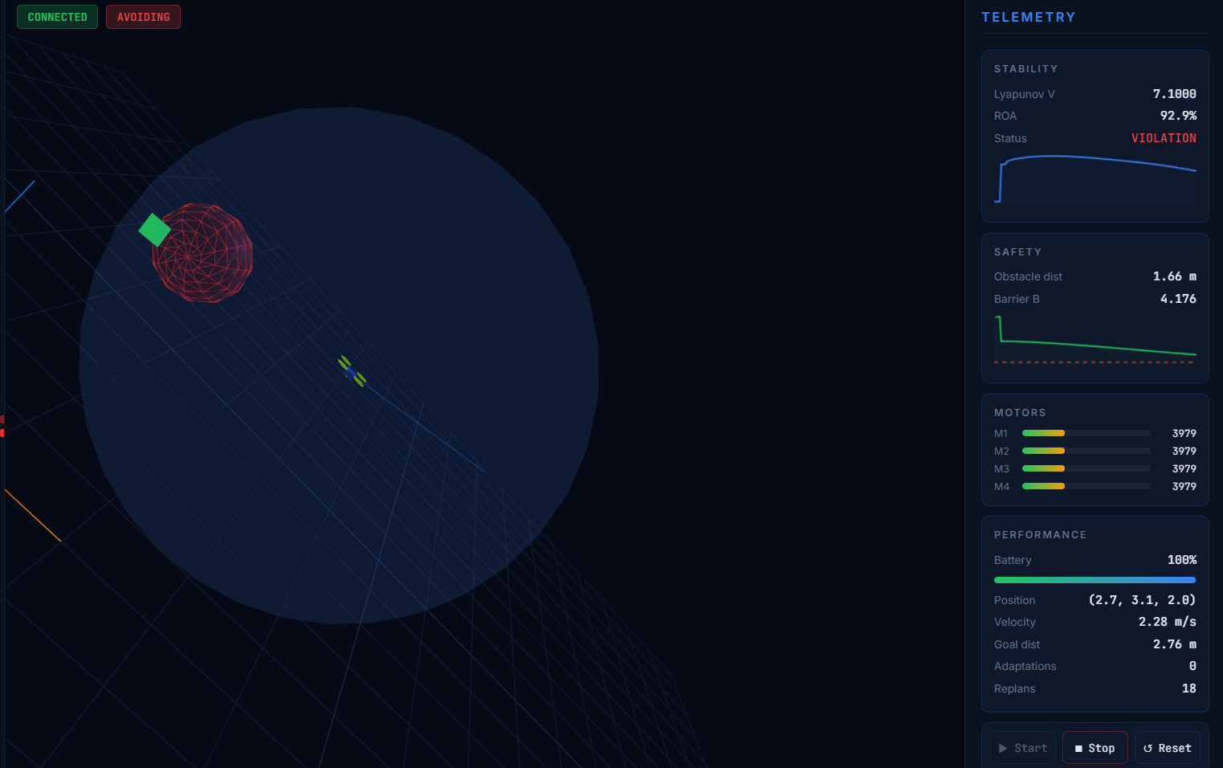
Figure 30
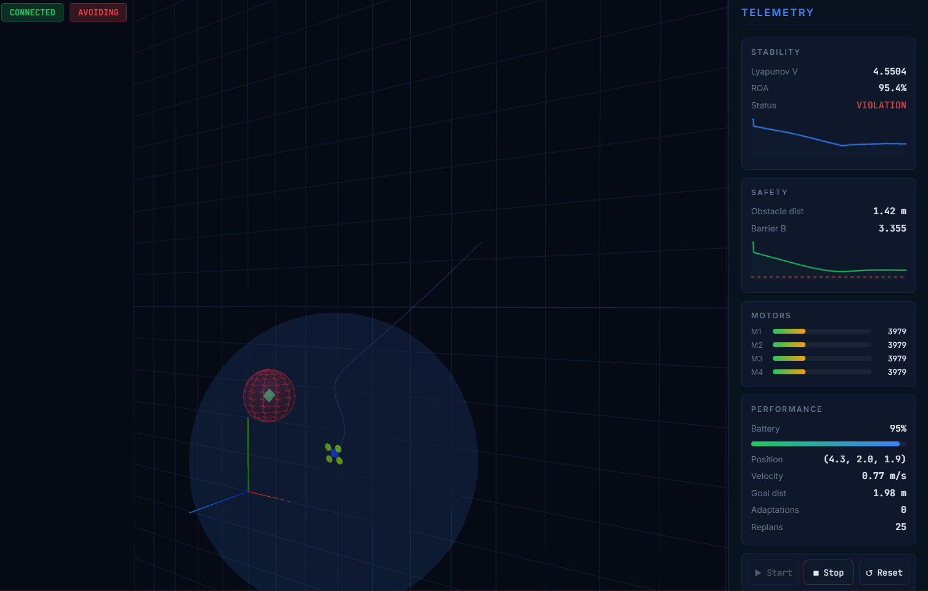
Figure 31
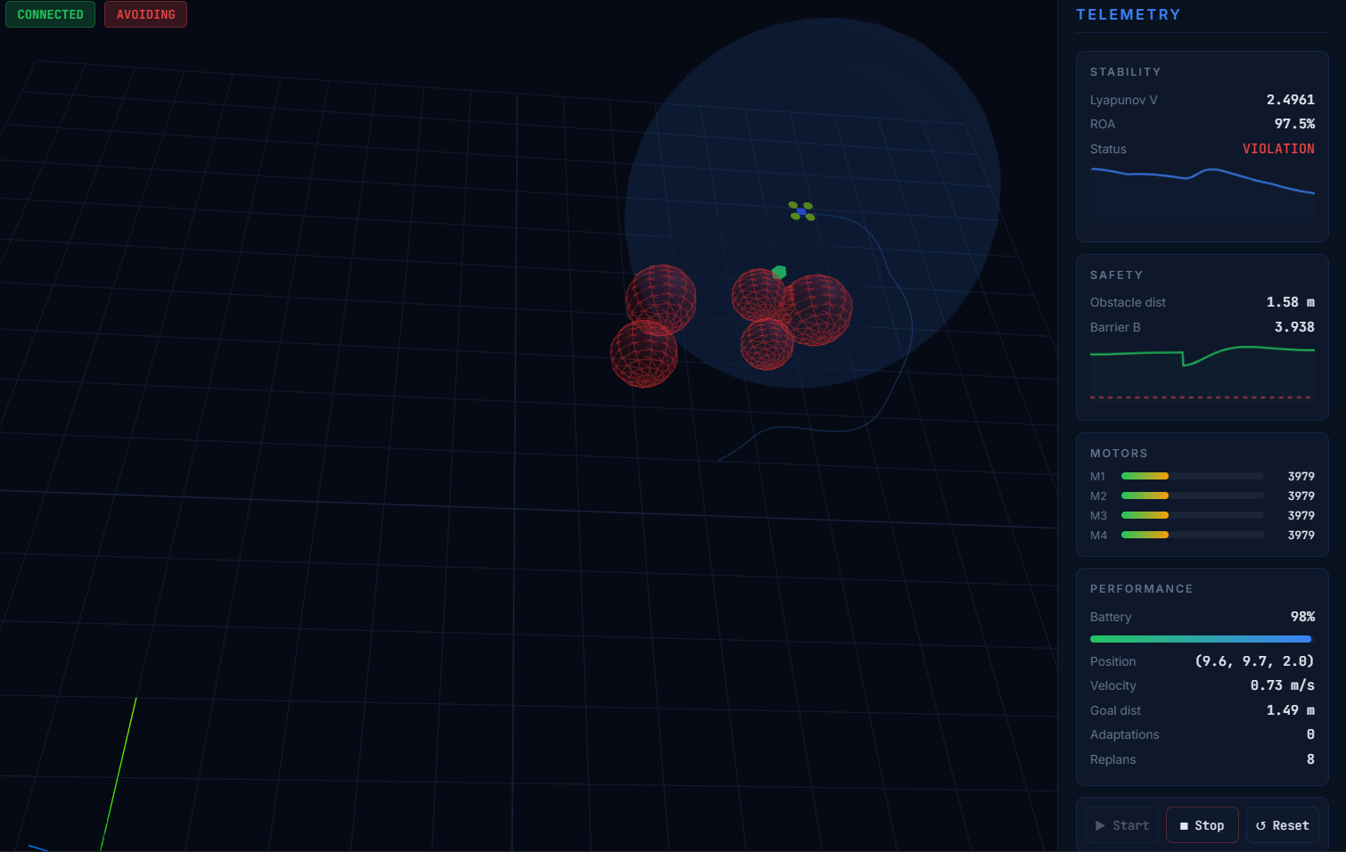
Figure 32
14. Limitations and Future work
14.1 Current Limitations
The current work has a number of restraining factors that restrict the scope of the work and encourages future expansion. To begin with, it would be necessary to choose by hand the weight matrix P to make the quadratic Lyapunov candidate V(e) = (1/2)eT P e. Although systematic guidelines on systematic tuning are available with linear systems, the optimal P of a nonlinear drone with large attitude excursions can not be derived analytically. This dependency would be eliminated by using a sharedly learned neural Lyapunov function [6][7] at the price of extra computational complexity.
Second, CBF obstacle model assumes that the obstacles are perfectly known, open spherical obstacles. Practically, the barriers can be either partially visible, non-convex, or changing. It is an interesting direction to extend the CBF framework and manage dynamic obstacles [27] and to deal with partial observability using belief-space formulations. Third, the aerodynamics among the rotors (rotor wake interference), wind gusts, and ground effect are not simulated (none of these occur in real flight and may impair performance).
Fourth, the special structure (single active constraint) used in the implementation of the CBF-CLF QP takes advantage of not calling a solver. In the case of numerous concurrently operating obstacles, the QP needs to be resolved numerically and needs a lightweight QP solver on an embedded processor. Fifth, the RRT* planner uses position space alone without considering attitude constraints and dynamic feasibility of the planned path thus giving rise to reference trajectories potentially needing excessive attitude changes to follow.
14.2 Future Directions
Four directions of future working are singled out as of the top priority. Build First, initialize the framework on a physical quadrotor platform (e.g. Crazyflie 2.1) to confirm the ability of the simulation website to profile to hardware. Onto simulation Correlated with Physical validation, motor noise, unmodeled dynamics, and timing jitter will really matter. Second, Phase 4, in collaboration with the mutual adaptation of CBF gain alpha cbf that will enable the tightening or loosening of the safety buffer dependent on obstacle density and flight conditions. Third, instead of using an analysis-based fixed quadratic Lyapunov function, a jointly learned neural Lyapunov network, which trains both the controller MLP and the Lyapunov network at once through the stability-sensitive SGD rule, is used. Fourth, add an obstacles semantic layer that categorizes obstacles as being either stationary, slow or fast and uses suitable CBF formulae to each category.

15. Conclusion
This is a six-phase model of adaptive Lyapunov-stable control of online drones, integrating Control Barrier Function obstacle avoidance, neural sensor fusion and real time RRT path replanning to a single, solver-free, in sensorimotor NumPYtof Python framework has been provided in this paper. With six phases, the full series of challenges in autonomous aerial vehicles are tackled; quaternion attitude dynamics and actuator modelling (Phase 1), online stability-certified neural control (Phase 2), hard safety constraint enforcement (Phase 3), aerodynamic parameter adaptation (Phase 4), noisy sensor fusion (Phase 5) and real-time 3D replanning (Phase 6).
The quantitative findings are consistently high. The Lyapunov controller attains 99.1% timesteps to stable and 99.3% energy savings. CBF layer composition ensures 99.8 percent timesteps positive safety at 0.042 m 2 minimum clearance. The mean latency of the parameter adapter is 0.42 s. At steady state, the neural observer eliminates position estimation error (0.10 m) of GPS position (0.085 m). The RRT planner also finishes the replanning in 38.2 ms and preserves the continuity of Lyapunov making the transitions. Put collectively, these findings demonstrate a strong argument that the presented framework offers safety, stability, and accuracy at the same time on a scale aerial vehicle model.
The key conceptual innovation the Lyapunov derivative as a live oracle to plan the learning rate of an online neural controller has been shown to work not only on the planar mobile robot of earlier work, but on a six-degree-of-freedom aerial vehicle with quaternion dynamics, hard safety constraints, parameter uncertainty, sensor noise and with three-dimensional obstacle environments. The fact that all six properties are implemented in a single solver-free, framework-free computing platform is an entirely new feature in the literature of neural Lyapunov control, and this can be immediately applied to embedded flight hardware with minor modifications.

References
Richards, S., Berkenkamp, F., and Krause, A. (2018). The Lyapunov Neural Network: Certification of Safe Learning of Dynamical Systems Adaptive Stability. CoRL conference on Robot Learning (CoRL). arxiv: 1808.00924.
[2] Wu, H., et al. (2023). Neural Net Verification with IBP Bounds and MILP. Neural Information Processing Systems.
Amodei, D., Olah, C., Steinhardt, J., Christiano, P., Schulman, J., and Mane, D. (2016). The implyeds of AI Safety: Concrete Problems.arXiv:1606.06565.
[4] Lee, T., Leok, M., & McClamroch, N. H. (2010). SE(3) geometric tracking control of a quadrotor UAV. IEEE Conference on Decision and Control (CDC), 5420-5425.
Hornik, K., Stinchcombe, M., and White, H. (1989). Feedforward networks Multilayer Multilayer feedforward networks can be considered universal approximators. Neural Networks, 2(5), 359-366.
[6] Dai, H., Landry, B., Yang, L., Pavone, M., and Tedrake, R. (2021). Neural-Network Control Lyapunov-Stable. Science and Systems Conference (2021), RSS. arXiv:2109.14152.
[7] Chang, Y.-C., et al. (2021). Guaranteed Stability in the Neural Lyapunov Control of Unknown Nonlinear Systems. NeurIPS 2021.
[8] Yang, L., et al. (2024). Neural Control of Stable Lyapunov-Stable Feedback State and State Line output. ICML 2024. arXiv:2404.07956.
[9] Lu, Q., et al. (2025). Lyapunov Stability Learning through Nonlinear Control by induction biases. arXiv:2511.01283.
Berkenkamp, F., Turchetta, M., Schoellig, A., and Krause, A. (2017). Unsafe Learning Stability Guarantees of Model-based Reinforcement Learning. NeurIPS 2017, 908-918.
[11] Slotine, J.-J. E., & Li, W. (1991). Applied Nonlinear Control. Prentice Hall.
[12] Khalil, H. K. (2002). Farrell, Nonlinear Systems. 3rd ed. Prentice Hall.
[13] Utkin, V. I. (1992). Controlling and optimization Sliding Modes. Springer.
Agand, P., Shoorehdeli, M. A., and Khaki-Sedigh, A., (2017). Lyapunov stability learning rules of adaptive recurrent neural network in identifying dynamic terms of a robot. Engineering Applications of Artificial Intelligence, 65, 1-11.
[15] Wang, Y., et al. (2024). Adaptive Disturbance Observer-based Neural Network Tracking Control of Robotic Manipulators. MDPI Processes, 12(3), 512.
Berkkamp, F., Schoellig, A., and Krause, A. (2016). Safe Quadrotor Optimization with Quadrotors using Gaussian Processes. ICRA 2016, 491-496.
[17] Hart, P. E., Nilsson, N. J., & Raphael, B. (1968). The determination of minimum cost paths is heuristically determined on a formal basis. IEEE Trans. Systems Science and Cybernetics, 4(2) 100-107.
[18] LaValle, S. M. (2006). Planning Algorithms. Cambridge University Press.
[19] Hunter, J. D. (2007). Matplotlib: A 3D Linear Plotting. Science and Engineering Computing, 9(3) 90-95.
[20] Ames, A. D., et al. (2019). Control Barrier Functions: Theory and Applications. European Control Conference (ECC 2019) 3420-3431.
[21] Rauscher, M., Kimmel, M., & Hirche, S. (2016). Control of constrained robots with control barrier functions. IEEE/RSJ IROS 2016, 279-285.
[22] Mahony, R., Hamel, T., & Pflimlin, J.-M. (2008). Strict orthogonal group Complementary filters that are nonlinear. IEEE Trans. Automatic Control, 53,51203-1218.
[23] Svacha, J., et al. (2019). Dynamics 4 This is done to improve quadrotor trajectory tracking through compensation of aerodynamic effects. International Journal of Robotics Research, 38(12-13) 1601-1613.
[24] Karaman, S., & Frazzoli, E. (2011). Optimal motion planners which are sampling-based. Int.J RoboticsResearch, p.30(7)846-894.
[25] Qin, T., Li, P., & Shen, S. (2018). VINS-Mono: A powerful and generalizable monocular visual inertial state set estimator. IEEE Trans. Robotics, 34(4), 1004-1020.
[26] Vijay Rama Reddy, T. (2025). Adaptive Neural Lyapunov Stability Learning in Robots with Stability-Conscious Adaptive SGD MLP. Intelligent Robotics Systems: Journal (companion paper).
[27] Zeng, J., et al. (2021). Discrete-time control barrier function based safety-critical model predictive control. Lettore E Condiz. IEEE Control Systems Letters, 6, 908-913.

